**University of Southeastern Philippines**

**College of Teacher Education and Technology**

**Tagum – Mabini Campus**

**Apokon, Tagum City**



***E-VOTAR: A WEB-BASED VOTING SYSTEM FOR LOCAL AND STUDENT COUNCIL ELECTIONS AT UNIVERSITY OF SOUTHEASTERN PHILIPPINES TAGUM UNIT***

**AN OUTLINE PAPER FOR**

**1TCP400 IT CAPSTONE PROJECT**

**ADVISER:**

**MR. ARCHIE A. CENAS**

**SUBMITTED BY:**

**ANG, SWEET FRACHETTE L.**

**RAÑA, LORJOHN M.**

**VARGAS, KRISTINE MAE L.**

**JULY 18, 2024**

**Table of Contents**

**Title Page No.**

CHAPTER I 8

Project Context 8

Purpose and Description 10

Objectives of the Study 11

Scope and Limitations 13

CHAPTER II 14

Related Systems 18

Synthesis 24

Technical Background 25

Software Requirements 26

Hardware Requirements 27

User Classification 28

Network Requirements 29

System Architecture 29

CHAPTER lll 31

System Development Methodology 31

Use Case Diagram 35

Use Case Description 40

Functional Requirements 71

Non-Functional Requirements 73

Activity Diagram 73

System Flowchart 75

Context Data Flow Diagram 85

Entity Relationship Diagram 89

Prototype 90

Reference 121

**List of Tables Page**

Table 2.1 Comparison of Related Systems 23

Table 2.2 Software Requirements 26

Table 2.3 Hardware Requirements 27

Table 2.4 User Classification 28

Table 2.5 Network Requirements 29

Table 3.1 System Requirements of the Application 33

Table 3.2 Login Use Case Description 40

Table 3.3 Forget Password Use Case Description 41

Table 3.4 OTP Use Case Description 42

Table 3.5 Start Election Period Use Case Description 43

Table 3.6 Close Election Period Use Case Description 44

Table 3.7 View Statistical Vote Count Use Case Description 45

Table 3.8 View Candidates Use Case Description 46

Table 3.9 View Users Use Case Description 47

Table 3.10 View System Logs Use Case Description 48

Table 3.11 Print/Export Candidates Use Case Description 49

Table 3.12 Print/Export User Use Case Description 50

Table 3.13 Print/Export Election Result Use Case Description 51

Table 3.14 Add/Edit Admin as Use Case Description 52

Table 3.15 Delete Admin Use Case Description 53

Table 3.16 View Student Council Election Result Use Case Description 54

Table 3.17 View Local Council Election Result Use Case Description 55

Table 3.18 Add/Edit Candidate Use Case Description 56

Table 3.19 Delete Candidate Use Case Description 57

Table 3.20 Add/Edit Voter Use Case Description 58

Table 3.21 Delete Voter Use Case Description 59

Table 3.22 Add/Edit Partylist Use Case Description 60

Table 3.23 Remove Partylist Use Case Description 61

Table 3.24 Vote in Student Council Use Case Description 62

Table 3.25 Vote in Local Council Use Case Description 63

Table 3.26 View Vote Summary Use Case Description 64

Table 3.27 View Tally Votes in Student Council Use Case Description 65

Table 3.28 View Tally Votes in Local Council Use Case Description 66

Table 3.29 View Statistical Data of Number of Users Use Case Description 67

Table 3.30 View Active Users Use Case Description 68

Table 3.31 Remove Active User Use Case Description 69

Table 3.32 View Statistical Data of Inactive Users Use Case Description 70

Table 3.33 Functional Requirements 72

**List of Figures Page**

Figure 2.1 Helios Home Page 18

Figure 2.2 O.V.S Core Dashboard 19

Figure 2.3 Cerilles State College- Dumingag Campus Voting System Voting Dashboard 20

Figure 2.4 CSPC voting system login page 21

Figure 2.5 Ivote System 22

Figure 2.6 System Architecture 30

Figure 3.1 Agile Methodology 31

Figure 3.2 Planning Phase 33

Figure 3.3 Use Case Diagram of UseP E-Votar for SuperAdmin User 35

Figure 3.4 Use Case Diagram of UseP E-Votar for Admin/Staff User 36

Figure 3.5 Use Case Diagram of UseP E-Votar for Watcher User 37

Figure 3.6 Use Case Diagram of UseP E-Votar for Technical Officer User 38

Figure 3.7 Use Case Diagram of UseP E-Votar for Voter User 39

Figure 3.8 Activity Diagram of E-votar Application 74

Figure 3.9 System Flowchart of E-Votar Login Administrative Users 76

Figure 3.10 System Flowchart of E-Votar Login Voter Users 78

Figure 3.11 System Flowchart of E-Votar Superadmin User 80

Figure 3.12 System Flowchart of E-Votar Admin/Staff User 81

Figure 3.13 System Flowchart of E-Votar Watcher User 82

Figure 3.14 System Flowchart of E-Votar Technical Officer User 83

Figure 3.15 System Flowchart of E-Votar Voter User 84

Figure 3.16 Context Data Flow (Level 0) Diagram E-votar Application 85

Figure 3.17 Data Flow Diagram (Level 1) of E-votar System 87

Figure 3.18 Physical Data Flow Diagram of E-votar System 88

Figure 3.19 Entity Relationship Diagram (ERD) of E-Votar 89

Figure 3.20 (A) (B) (C) (D) (E) (F) and (G) Mock-up of the e-votar system for superadmin user. 92

Figure 3.21 (A) (B) (C) (D) and (E) Mock-up of the e-votar system for admin user 94

Figure 3.22 (A) (B) (C) and (D) Mock-up of the e-votar system for watcher users 96

Figure 3.23 (A) and (B) Mock-up of the e-votar system for technical officer users 97

Figure 3.24 (A)(B)(C)(D)(E)(F)(G) and (H) Mock-up of the e-votar system for voter users 101

Figure 3.25 (A)(B)(C)(D) and (E) Mock-up of the login process in the e-votar system 104

Figure 3.26 (A)(B)(C)(D)(E) and (F) Mock-up of the e-votar system in mobile interface for superadmin user 105

Figure 3.27 (A)(B)(C)(D) and (E) Mock-up of the e-votar system in mobile interface for admin user 107

Figure 3.28 (A)(B)(C) and (D) Mock-up of the e-votar system in mobile interface for watcher user 109

Figure 3.29 (A) and (B) Mock-up of the e-votar system in mobile interface for technical officer user 111

Figure 3.30 (A)(B)(C)(D)(E)(F)(G) and (H) Mock-up of the e-votar system in mobile interface for voter user. 113

Figure 3.31 (A)(B)(C)(D) and (E) Mock-up of the login process of the e-votar system in mobile interface 115

Figure 3.32 Development Phase 117

Figure 3.33 Testing Phase 118

Figure 3.34 Deployment Phase 119

# CHAPTER I

**INTRODUCTION**

## Project Context

In an educational institution, student organization plays a pivotal role in the development of the institution. In connection, voting systems are important in selecting student leaders to represent the student body in the University. Securing, and maintaining the integrity, confidentiality, and accessibility of the voting system is crucial for every election process.

Traditionally, voting is done manually through pen and paper, counted, and tallied manually. This manual process is prone to security breaches that alter the integrity of the election. Additionally, reports take a long time to generate, there are many inaccuracies in the data, the duration of the voting process is too long and there are delays in the counting process. As technology advances, cyberattacks and online anomaly have arisen, these raise questions about the capability of an online voting system to safeguard and protect the confidentiality and integrity of the voting process and results produced by these online systems. According to the study of Ahmad et al. in 2015 electronic voting systems encounter limitations such as vote fraud and manipulation during the counting process, instances of multiple voting and impersonation due to inadequate authentication techniques, and a lack of verifiability. Another study by Darmayunata et al. in 2020 discussed the practical challenges and security issues encountered while implementing an e-voting system at SMP Negeri 10 Pekanbaru school. The deficiency in the electoral process can lead to doubt of the voters and make it difficult to trust the votes that are recorded and counted.

In the Philippines, a study in a Philippine State University revealed limitations in their voting system, such as lack of security measures leading to a possibility of manipulation of votes. The study also suggests enhancing voting security and integrity, and that includes integrating biometric security for voter verification, restricting network connectivity, and assuring compatibility across several platforms.

In the University of Southeastern Philippines, the Commission on Election (Comelec) body of the University utilizes both manual and an online voting system known as the USeP Voting System (UVS). However, these efforts of the Commission to accomplish its goals in having a reliable, trustworthy, and transparent election are often questioned by numerous participating students. In the last election conducted at the USeP Obrero Campus, students and candidates questioned the system’s capability when UVS glitched leading to the votes tallied becoming zero. Furthermore, there were concerns regarding the system’s security and reliability, as their data protection is insufficient and the password only used birthdates which were prone to unauthorized access. With this incident there is still a considerable gap in the deployment of security measures including identity verification methods. Moreover, these anomalies in the election stress the necessity of a more secure and robust system for the votes of the students. These voting anomalies were not unfamiliar to the students at the University of Southeastern Philippines, Consequently, during elections at the USeP Tagum-Mabini Campus, students have expressed similar concerns regarding the integrity of their votes. In addition, to the lack of security of the system. Thus, we plan to address the concerns of the users.

Addressing this gap is critical in an institution for it holds a significant factor that affects the institution’s credibility and integrity, likewise, paving a way into a more reliable and anomaly free voting system. Through the development of this study the voters and users can cast their votes with confidence and trust to the system in safeguarding the authenticity, and integrity of their votes, this system will benefit the University of Southeastern Philippines Tagum Unit students in exercising their right to vote and to select future student leaders of the university without hesitation of the system's capability. Moreover, this will also help fortify the credibility of the USeP Tagum Mabini campus voting process and is expected to gain the trust and confidence of the public towards the institution's internal governance.

## Purpose and Description

This study introduces the development of a web-based voting system, that is USeP E-votar system. This system will use intranet and combines security elements designed to protect users' information and uphold the University’s Comelec body’s goals in having a robust, trustworthy, and transparent election. Furthermore, it is a multi-platform designed to be responsive and accessible across various devices, such as desktops, laptops, and smartphones. In addition, before proceeding with the login process, the voters will be informed that the system complies with the Data Privacy Act. By logging in, they consent to the collection, use, and processing of their personal information in accordance with the act. This ensures that your information is handled responsibly and securely.

The purpose of this study is to develop a voting system for the University of Southeastern Philippines Tagum Unit in conducting the yearly student and local council election spearheaded by the governing commission on the election body of the university. This system will cover the lacking functionality with the application of an innovative voting system that will include robust security mechanisms to prevent access to those who are not authorized and ensure the security and integrity of every information obtained and processed. These security techniques include IP address tracking, camera liveliness verification, facial recognition, multi-factor authentication, data encryption, detailed logs, and steganography. Furthermore, it incorporates real-time result tabulation, anonymity, and thorough logging to increase transparency. Moreover, a thorough audit trail guarantees that the procedure can be depended on. In addition, a module for the dissemination of election related information will also be created.

## Objectives of the Study

This study aims to develop a secured automated web-based voting system for the local student COMELEC of USeP Tagum Unit.

Specifically, it aims to:

1. Implement Roles-based Access Control (RBAC) which includes mechanisms for:
   1. Super-admin with his/her access rights, to wit:
      1. Administrative Dashboard for overall management and administration;
      2. Import and export of relevant data specifically:
         1. Voters list;
         2. Candidates;
         3. Partylist;
         4. Official election results and turnouts
      3. Generate relevant reports on the election results and turnouts including:
2. Winning candidate in each position;
3. Summary of election results and voter turnouts
   1. Admin
      1. Import and export of relevant data specifically:

a. Voters;

b. Candidates;

c. Partylist;

* + 1. Management for:

1. Voters;
2. Candidates;
3. Partylist;
   1. Technical Officer
      1. Manage Active users
      2. Backup
   2. Watcher
      1. Oversee Real-time results
   3. Voter

1.5.1 cast vote

1. Integrate modules for:

2.1 Real-time vote tallying and counting;

2.2 and Tabulation results

1. Monitor in real-time the system activities to exercise transparency and integrity of election process and data using action logs of super admin, admin, technical officer, and voter
2. Implement security measures using:
   1. Steganography encryption technique for vote secrecy and verification;
   2. MFA for user authentication and authorization;
   3. Facial recognition technique to verify user’s liveliness using open cv
3. Design real-time monitoring and display of:

5.1. Tabulated votes earned by each candidate in each position

1. Integrate web-based subsystem for information dissemination

## Scope and Limitations

The USeP E-votar is a web-based voting system for the electoral system for the COMELEC and student body of University of Southeastern Philippines Tagum Unit. It encompasses the entire election procedures from voter registration through generation of election results and termination of election period. The features of the proposed system are mainly emphasized on implementing security techniques including IP address tracking to ensure that only one student can use one account, at the same time, camera liveliness to check the voters' actions, facial recognition to verify the voter 's identity, multi-factor authentication to further secure the account of the user, lastly steganography which is able to hide important data from unauthorized users. The users of our system are the students, student leaders and the voters of the student leadership.

Moreover, it will automate the entire electoral process by ensuring that each voter receives the correct votes for their specific election. The voting process will be monitored in real time, giving the COMELEC and student leaders the most up-to-date information on voter turnout and any irregularities. The election data, particularly the secure storage and transfer of votes, will be automated to minimize human error and speed up the tallying process. Furthermore, the system will generate reports and election results, and facilitate the termination of the election period.

However, there are certain limitations with the system and that includes not having a dedicated mobile application, but it is designed to function and be accessible on any mobile device. The system will be limited to students who are currently enrolled and registered in the university, and the election will be available only during the specified period. Furthermore, users can only vote within the school premises because the voting system operates with an intranet. If the Superadmin is not from Tagum City, they have the authority to grant access to authorized individuals as they see fit.

# CHAPTER II

**REVIEW OF RELATED LITERATURE AND SYSTEMS**

The introduction of digital technology has transformed many aspects of daily life, including the election processes in educational institutions. According to Damawan in 2021 online voting systems in schools provide another alternative to the limitations of traditional manual voting methods. Studies from the United States, Europe, and Asia show the increasing use of electronic voting systems in school elections, driven by the need for efficiency, transparency, and student engagement. Furthermore, according to a study by Ikrissi et al. in 2024 suggest that E-voting provides various benefits over traditional voting systems and that includes enhanced efficiency, accessibility, and accuracy. However, it also presents a few challenges and problems that need to be addressed to ensure that the voting process remains transparent, private, secure, and maintains its integrity (Ikrissi et al. in 2024). In addition, current systems generally lack strong security measures against advanced cyber-attacks, making them prone to potential breaches, transparency problems, and vote manipulation (Wahid et al. 2023). Overall, school voting systems highlight the potential for technical advancement to transform political processes in academic settings, while also suggesting the need for accessible and effective security measures to ensure fair and inclusive participation.

The adoption of e-voting systems in educational institutions is gaining popularity in the global scene, including in the Philippines, aiming to improve the efficiency, accuracy, and accessibility of student elections. However, their implementation presents challenges that need to be addressed to ensure effectiveness and reliability. According to a study by Montizon, J. G. in 2022 highlighted the effectiveness and satisfaction of students with the use of the Voting System at Don Mariano Marcos Memorial State University**,** where the system provided a digitally transparent and interactive voting experience. Despite the success, the study suggested further improvements, such as developing enhanced security measures on the system and continuous evaluation, improvement and modification to avoid voting fraud and manipulation. These improvements would address security concerns and increase system versatility, making e-voting systems much more safe and secure and widely adoptable in academic setups throughout the Philippines.

The integration of facial recognition technology into online voting systems represents a notable advancement in securing electoral processes. As the need for online voting rises, mostly because of its benefit, the need for robust security measures becomes increasingly crucial. Recent studies recommended utilizing deep learning techniques, specifically the Convolutional Neural Networks (CNNs), to develop a secure online voting system that utilizes facial recognition for voter authentication. This method ensures that only confirmed voters can cast their votes, thus preventing illegitimate votes as well as boosting the general safety and security of the electoral process. Furthermore, the research study shows that biometric verification via face recognition can provide a safe and secure, reputable, and also effective solution for online voting ensuring the user's authenticity as well as securing the voting process (Abdul et al. 2023).

Steganography offers another layer of security by concealing data within digital images, making it an effective tool for protecting voter information. According to a study by Rura et al., in 2020 suggests that using steganography one can secure data and it also gives a new effective method of protecting and enforcement of copyrights and licenses. Steganography through secret information can be used to confirm important business transactions and user authentication.

To further enhance security, camera liveliness detection technology can be integrated into the system. According to a study by Zawar et al. in 2023, CNN combined with liveliness detection performs really well in real-time scenarios for face anti spoofing. Furthermore, various attacks have also been tried and tested. Liveliness detection also ensures that the individual presenting their face for authentication is a live person rather than a static image or pre-recorded video, thus preventing spoofing attacks. A study also highlights that this technique can improve user authentication by protecting the replay photo attacks and having a security feature such as object identification (Khairnar et al. 2023).

The implementation of real-time monitoring of votes, tally and results is a significant aspect of voting systems. According to a study by Kebande et al., in 2021 highlights the importance of real-time monitoring as a security component for possible cyber threats and attacks. Furthermore, preventing multiple votes from the same IP address will be integrated to ensure that no other unauthorized access can vote at the same time.

In addition, another important aspect of security highlights the importance of multi-factor authentication to improve online data security (Das et al. 2019). Furthermore, according to Williamson et al. in 2021 it seems inevitable that multifactor authentication (MFA) will become standard for confirming a user’s identity. In addition, biometric technologies are gradually replacing traditional password and token-based authentication systems. Passwords and security tokens can be stolen, lost, or forgotten; however biometric features are very impossible to fake (Yang et al. 2019). Multi-factor authentication will strengthen the security, especially in preventing unauthorized access to the system, thus providing an additional layer of security in a system.

In addition, another security measure that can protect votes AES's adoption in online voting systems offers enhanced security by encrypting voter information and communications, thereby lowering risks associated with unauthorized access and tampering of votes. Moreover, the integration of AES with protocols such as Kerberos adds another layer of defense by securing communication between a voter and server. New advances in AES deployment will produce better improvements in online voting security.

Meanwhile, a capstone project Ivote is a web based and mobile application voting system in Tagum City. The students are able to vote in the web and mobile application that can generate reports, and calculate and display winners. However, the systems overlook critical security measures, leaving voter information vulnerable to manipulation. To address this, E-votar employs a robust multilayered security approach. This includes IP address tracking, camera liveliness verification, facial recognition, multi-factor authentication, data encryption, detailed logging, and steganography.

The aforementioned technologies and studies highlight the importance of the online voting system to address the problems of ensuring the legitimacy and authenticity of voting procedures and voting results. As a solution, the proposed E-Votar system employs different technologies and features to safeguard the overall electoral process of student organizations University particularly in the Tagum Unit.

## Related Systems

Below are the related systems that have connection to our capstone that provided us with inspiration. These systems highlight various aspects of electronic voting, security, and automation, which have influenced the design and functionality of the USeP E-votar system.

**Helios**

Helios is a system for voting that allows voters to cast votes from anywhere with internet access. Voters in the Helios elections must first register and then log in using unique passwords that assure security and privacy. Once logged in, you may safely input your vote, which will be encrypted to ensure the privacy of your choices.

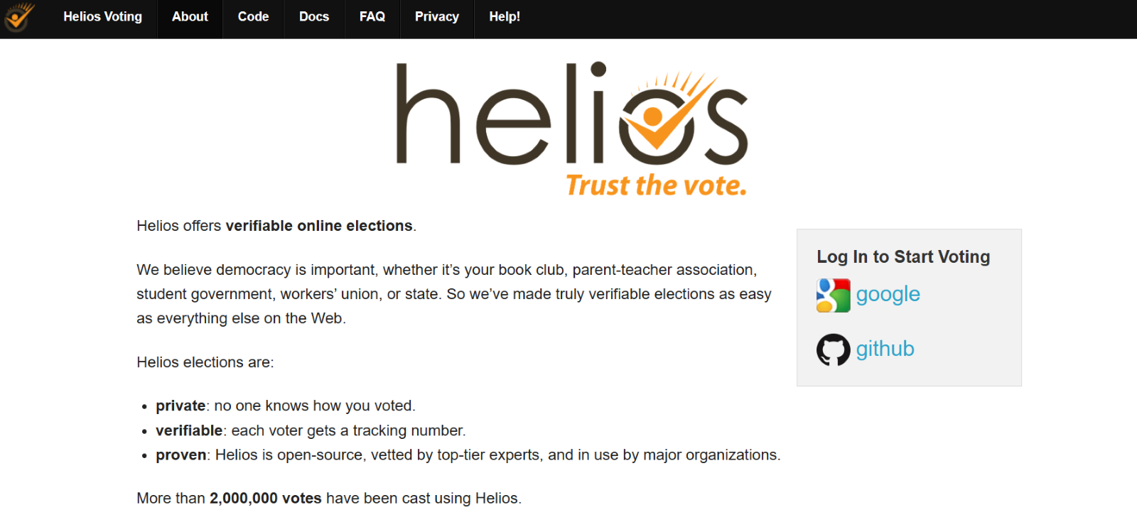

Figure 2.1 Helios Home Page

Figure 2.1 shows the Helios Homepage that shows the Login box and the users are able to choose between google or GitHub to login.

**SOV system**

Adding to these efforts, another system created by Clarian Makungu, Rose Muthue Munyao, Josephat Karani Mwai provides students with an online voter registration platform through which they can register and log in as students, delegates, and candidates. With SOV system each registered user is given a password for safe login. The system includes an interactive platform where voters and candidates can participate, allowing candidates to run their campaigns. It facilitates preliminary voting by providing graphical percentage representations of the outcomes. Additionally, users can like candidates, and the most liked candidate is deemed the most popular. The system computes and delivers election results for all posts, as well as generates comprehensive election process reports.

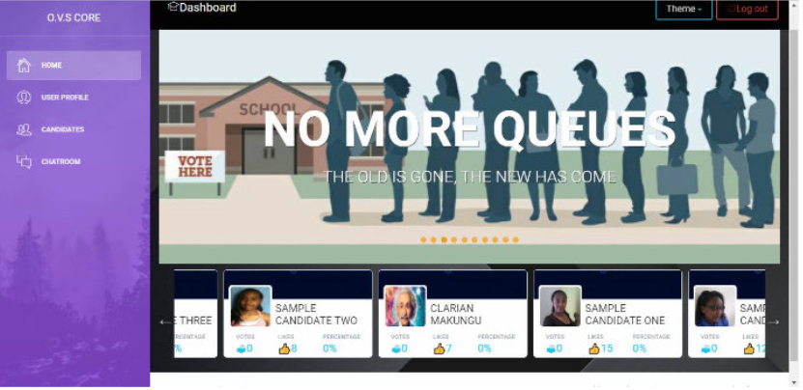

Figure 2.2 O.V.S Core Dashboard

Figure 2.2 shows the O.V.S Core dashboard with a navbar on the side. The candidate is also displayed in the dashboard.

**Cerilles State College- Dumingag Campus Voting System**

Furthermore, another related system in the national setting created by J.H. the student council of Cerilles State College- Dumingag Campus, located in Zamboanga del Sur province, created a web-based application that was tailored to the functional needs determined during data collecting. The application allows voters to conveniently cast their ballots while guaranteeing their eligibility to vote. Additionally, election authorities can obtain election results promptly and prepare any necessary printed reports (Matos, 2023).

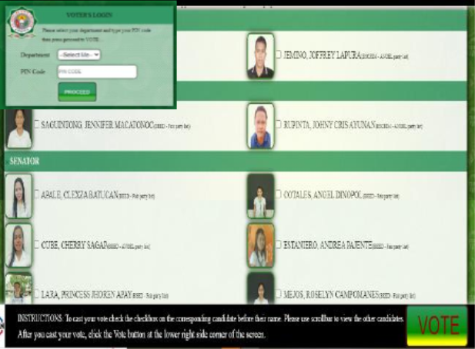

Figure 2.3 Cerilles State College- Dumingag Campus Voting System Voting Dashboard

Figure 2.3 shows the voting dashboard. This is where the voters choose their candidates and cast their votes.

**uVote**  
 Another similar voting system by Camarines Sur Polytechnic Colleges developed by College of Computer Studies (CCS) at CSPC design as an alternative for traditional voting. The voter will be directed to user login where you have to login using CSPCe email. Moreover, if the email address provided is not updated you can simply click the link and it will direct you to another page where you will be asked for student ID and CSPC email address.

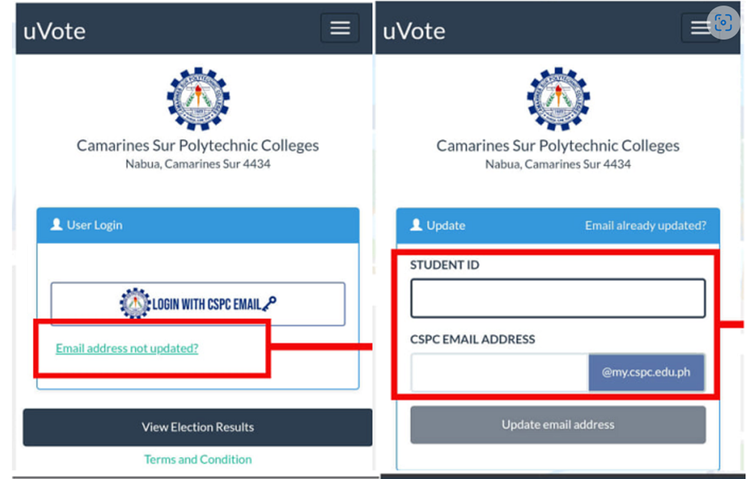

Figure 2.4 CSPC voting system login page

Figure 2.4 shows the login page of the voting system. After logging in you will be directed to the dashboard. The other page shows how to update users email address.

**Ivote**

Building on the capabilities demonstrated by Ivote system, a capstone project by the Bachelor of Science in Information Technology which was developed by Kimberly Francisco, Marielle Magbutong, Gerosefel Ranque to organize elections in the University of Southeastern Philippines. The system can allow students to cast their vote online. The system can set events, monitor, and produce reports. In addition, they implemented facial recognition for validating user accounts.

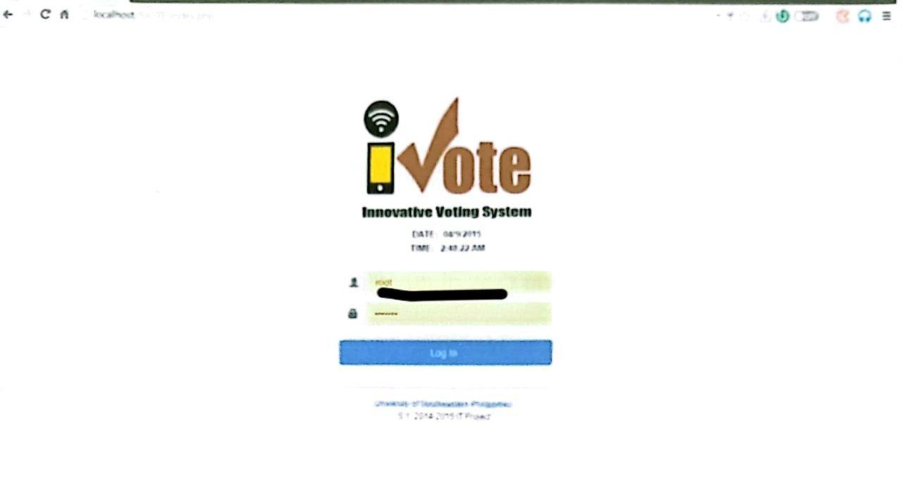

Figure 2.5 Ivote System

Figure 2.5 shows the login page of the voting system. After logging in you will be directed to the dashboard

**Table 2.1** Comparison of Related Systems

|  |  |  |  |  |  |  |
| --- | --- | --- | --- | --- | --- | --- |
| **Features** | **Helios** | **SOV Core** | **Cerilles State College- Dumingag** | **uvote** | **Ivote** | **E-votar** |
| Voting system | ✔ | ✔ | ✔ | ✔ | ✔ | ✔ |
| Casting Votes | ✔ | ✔ | ✔ | ✔ | ✔ | ✔ |
| Biometric Recognition | ✔ | X | X | X | X | ✔ |
| Camera liveliness verification | X | X | X | X | X | ✔ |
| Steganography | X | X | X | X | X | ✔ |
| IP Address tracking | ✔ | ✔ | ✔ | X | X | ✔ |
| Real -time result | ✔ | ✔ | ✔ | ✔ | ✔ | ✔ |

## Synthesis

Table 2.1 shows the comparison of related systems. The researchers found three comparable voting systems that support the USeP Voting System. One of these voting systems operates in mobile application while the other two is a web-application.

All these voting systems, including Helios, SOV Core,Cerilles State College- Dumingag, uVote, Ivote: An online voting system for local and student council elections at university of southeastern Philippines Tagum Unit implements security techniques include IP address tracking, camera liveliness verification, facial recognition, multi-factor authentication, and steganography.

The related system above may have many functionalities; however, they do not implement security techniques such as IP address tracking, camera liveliness verification, facial recognition, multi-factor authentication, and steganography for securing the data of the voters and maintaining the integrity, confidentially and transparency of the electoral process.

### 

### 

### 

## Technical Background

E-Votar: An Online Voting System for Local and Student Council Elections at the University of Southeastern Philippines Tagum Unit it aims to secure the integrity of votes, and the overall electoral process while ensuring a seamless student election.

PHPStorm will be used as the integrated development environment (IDE) to develop this system. This IDE is one of the most widely used by developers. The developers will also utilize WAMP a windows-based web development platform that allows you to create dynamic web applications using Apache2, PHP, MySQL, and MariaDB. The developers will use MySQL, one of the most used open-source Relational Database Management Systems (RDMS) using a basic Client-Server Model. It uses the well-known query language, Structured Query Language (SQL), which enables users to do all Create, Read, Update, and Delete (CRUD) actions (Dsouza, D., 2022). In addition, Adobe Photoshop and Figma will also be used for the user interface design, wireframe and the overall prototyping of the project. Furthermore, to ensure that the E-votar voting system is responsive on mobile devices, the developers will use tailwind, a popular front-end framework that provides responsive, mobile-first components.

### 

## Software Requirements

This table shows the software tools that will be utilized to create the project. These are chosen by the developers based on the project's requirements and scope.

**Table 2.2** Software Requirements

|  |  |
| --- | --- |
| **SOFTWARE** | **REMARKS/RECOMMENDATION** |
| Web Browser: Latest version of Chrome | A web browser is a piece of software that is used to access and manage websites. |
| Operating System: Windows 8/11 (64-bit) | An operating system is the foundational software that manages computer resources. Windows 8/11 (64-bit) ensures compatibility with development tools, databases, and web servers. It provides a stable environment for coding, testing, and debugging. |
|  |  |

Table 2.2 shows software requirements to be used in developing the project.

## Hardware Requirements

This table shows hardware tools to be used in developing the project. These are determined by the developers based on the requirements and scope covered in the project.

**Table 2.3** Hardware Requirements

|  |  |
| --- | --- |
| **HARDWARE** | **REMARKS/RECOMMENDATION** |
| Computer/Laptop with a web-cam and a speed of 1.2 Ghz | A computer or laptop will be needed to develop the system. |
| Processor: Intel i3 or i5 | An Intel i3 or i5 processor is used during the development to ensure performance and quick processing, supporting the smooth operation of development tools and handling complex tasks during coding and testing. |
| Memory (RAM): At least 4GB | At least 4GB of RAM is required during the development to ensure smooth multitasking and efficient handling of development tools, testing environments, and application processes. |
| Storage: At least 500GB HDD, recommended 256GB SSD for faster performance | At least 500GB of HDD storage is needed during the development for storing project files, databases, and development tools. A recommended 256GB SSD provides faster access speeds, improving overall system performance during coding, testing, and data handling tasks. |

Table 2.3 shows hardware tools to be used in developing the project.

User Classification  
 This section shows the classification of users who will use the system together with their roles, access, and responsibilities.

**Table 2.4** User Classification

|  |  |
| --- | --- |
| **People** | **Description** |
| Super Administrator | The super admin has the full information/overview of the election, including accessibility to all of voters and candidates' information. It has the sole authority to start and stop the election period. |
| Administrator | The administrator has full authority except for the setting of election period of the system in terms of maintaining, updating, adding, and editing the data and function of the system. |
| Election Watcher | The election watcher has the ability to oversee the real-time election result. |
| Technical Officer | The technical officer has the authority to view active users and has the ability to remove the user from the current activity. The T-O is in charge of database back up. |
| User (student voter) | The user can cast their vote. |

Table 2.4 shows all the users of the e-votar system.

## Network Requirements

This table shows the network requirement of the system. Users must be connected with the university’s network to access the system.

**Table 2.5** Network Requirements

|  |  |
| --- | --- |
| **ITEM** | **DESCRIPTION** |
| Internet | To access the system, an intranet will be used, and the desirable network speed is 100 mbps. |

Table 2.5 shows the network requirements for the E-votar System

## 

## 

## System Architecture

The system architecture presents network modeling and the network topology for the system deployment. The Client Layer, protected by a firewall, handles voter interactions and ensures a seamless user experience through HTML, CSS, and JavaScript, with mechanisms for cross-platform fraud detection. Voter requests are processed by the Application Layer, which includes user verification, input validation and sanitization, SQL injection management, authentication, session management, and authorization to maintain data integrity and security. The Middle Layer provides enhanced security features such as multi-factor authentication (MFA) and user liveness detection. The Database Layer manages and secures voting data using stored procedures, views, tables, and triggers, ensuring the reliability and accuracy of the voting process.

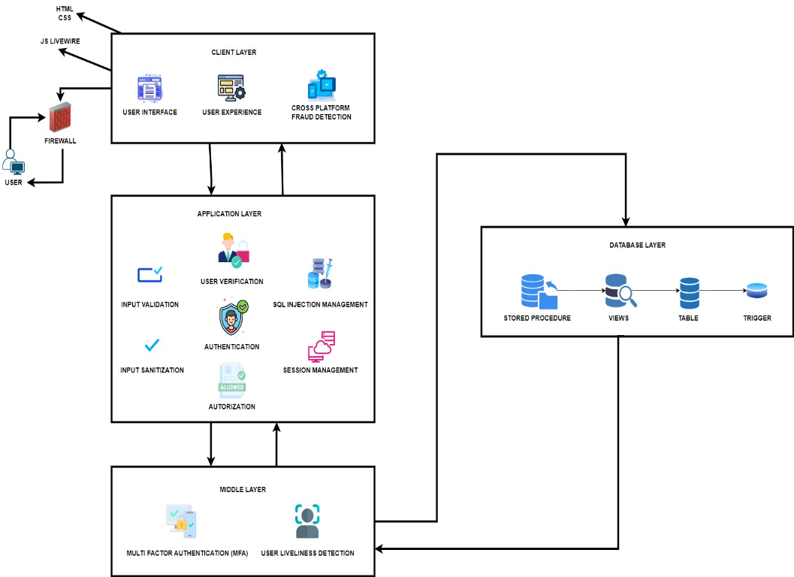

Figure 2.6 System Architecture

Figure 2.6 Shows the interaction among users, the server, and the administrator, where both users and the administrators store and retrieve information from the server.

# CHAPTER lll

**METHODOLOGY**

## System Development Methodology

It is vital to examine the most effective use of development strategy when designing an application, and one of these approaches is the Agile methodology. Agile methodology is a project management methodology that prioritizes ongoing cooperation and development while segmenting the work into manageable chunks (Atlassian, n.d.). This approach makes it easier to divide tasks among multiple individuals and keeps things moving forward. There are six stages of the agile software development life cycle and that is requirements, design, development, testing, deployment and review. Following these stages guarantees that the process runs smoothly, efficiently, and effectively.

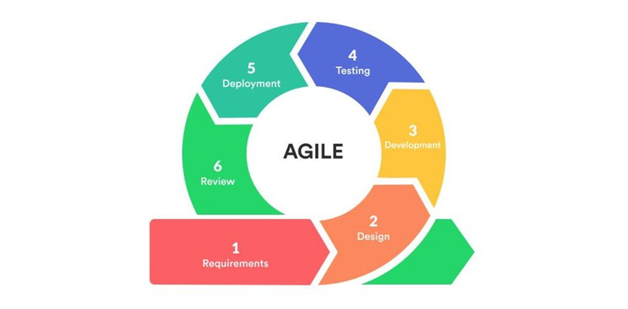

**Figure 3.1** Agile Methodology

Agile methods can be described as the capacity to adjust and react to change effectively and their approach revolves around grasping the dynamics of the environment, recognizing uncertainties, and devising strategies to accommodate them. Because of these features, the developers will incorporate this methodology into their development process.

**Phase 1: Requirements Specification**

One of the most crucial and fundamental steps in a development process is the first stage, the requirement specification phase. In this stage, the developers perform group discussions among its members, collecting ideas and perspectives for crafting strategies and plans for the development. To add to this, the study's goals and purpose are outlined along with the issues that the developers wished to solve. This stage also determines and considers the target user, the tools required for development, the project's scope and constraints, the technique to be used, and other crucial procedures.

During this phase, we, the researcher, will conduct initial meetings and discussion with the participating body of the University’s Commission on Election to gather requirements, information and understand the nature of their needs. After conducting initial meetings and discussions, we, the researchers will create and craft a product backlog with the commissions feedback and suggestions, prioritizing them based on importance and feasibility. Subsequently, the researchers will develop a high-level project plan that outlines key milestones and deliverable.

In this phase, the developers evaluate, define, and gather the system requirements to be used in the development process. The System Requirements Specification is utilized for this includes all the product requirements to be designed and developed accordingly. Through this process, the developers will be able to understand and determine the appropriate requirements necessary to the application.

**Table 3.1** System Requirements of the Application

|  |  |
| --- | --- |
| **SOFTWARE** | **DESCRIPTION** |
| Web Browser: Latest version of Chrome | A web browser is a piece of software that is used to access and manage websites. |
| Operating System: Windows 8/11 (64-bit) | An operating system is the foundational software that manages computer resources. Windows 8/11 (64-bit) ensures compatibility with development tools, databases, and web servers. It provides a stable environment for coding, testing, and debugging. |
|  |  |

Table 3.1 shows the system requirements in developing the web-based application. The following descriptions of the software required during the development process are also included in order to understand thoroughly the usage of each requirement in the application.

Deliverables:

1. Project Scope Document
2. Product Backlog
3. High level Project Plan

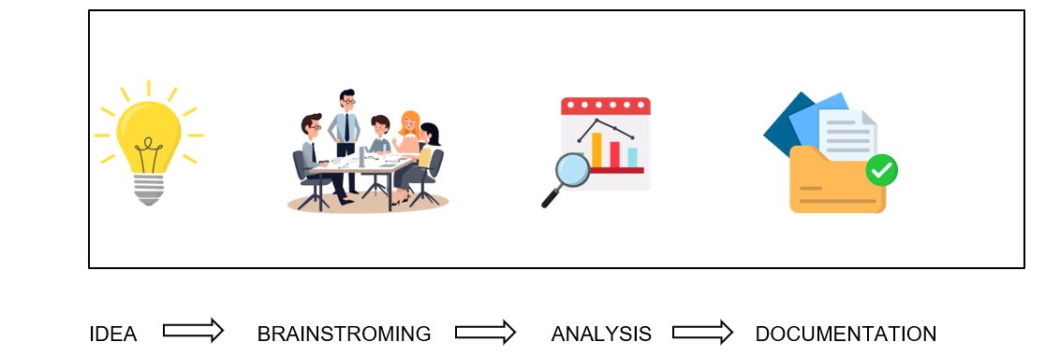

Figure 3.2 Planning Phase

Figure 3.2 shows the planning process in a sequential step that we researchers will follow accordingly. The process starts with the gathering and creation of an idea which encapsulates, understanding the problem, the gap, and the necessity of the study. In the creation of idea, the researchers will provide a brief description and provide a contextual general objective of the study. The next process is brainstorming phase, the research will organize numerous sequential meetings together with the concern governing body to discuss deeply the study and the constructed idea. The next process is the analysis stage wherein the researcher scrutinizes similarities in terms of functionalities of proposed system based on the idea compared to other existing related systems. The researchers will also analyze the purpose, objectives, scope and limitations, and commentary gathered and created during the past two processes. Lastly, the documentation stage, in this stage the researcher compiles all data gathered including but not limited to feedback, comments, evaluated, reviewed, and examined data to support the idea and solution introduced.

**Phase 2: Designing**

This section presents the design specification of the application which displays the flow of the system in order to understand and comprehend the processes involved within. These representations include the functional requirements, activity diagram, system flowchart, and the physical data flow diagram wherein each illustration has corresponding description to further understand the flow.

## Use Case Diagram

A use case diagram represents a map of interactions between the different system users and the system showing the relationship of interactions. Below is the Use Case diagram for the proposed UseP E-Votar system.

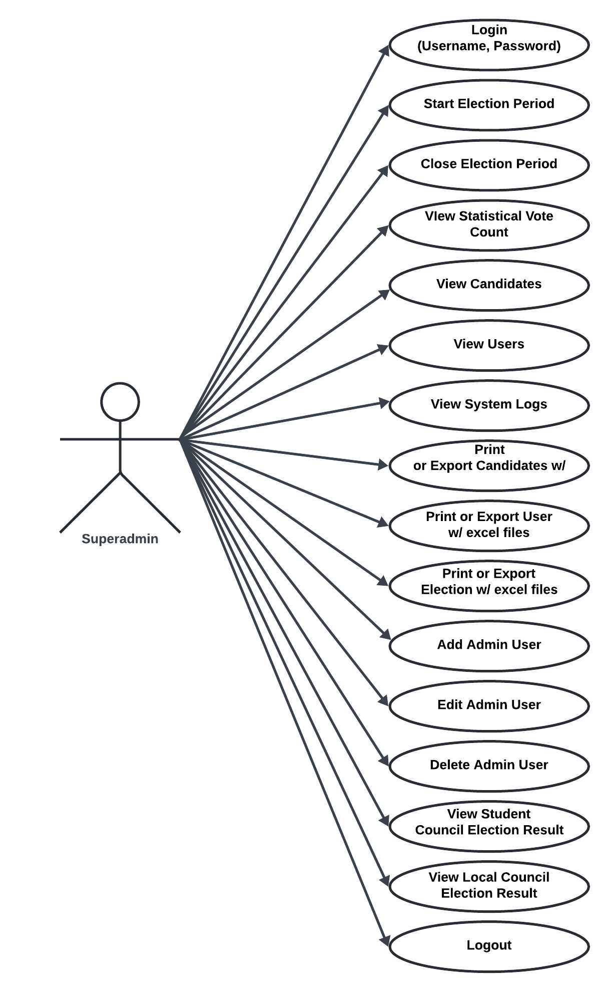

Figure 3.3 Use Case Diagram of UseP E-Votar for SuperAdmin User

Figure 3.3shows the interaction between the superadmin user and the system. This shows how superadmin utilizes the system. Similarly, it displays the different features and functionalities that a superadmin can access and manage within the system.

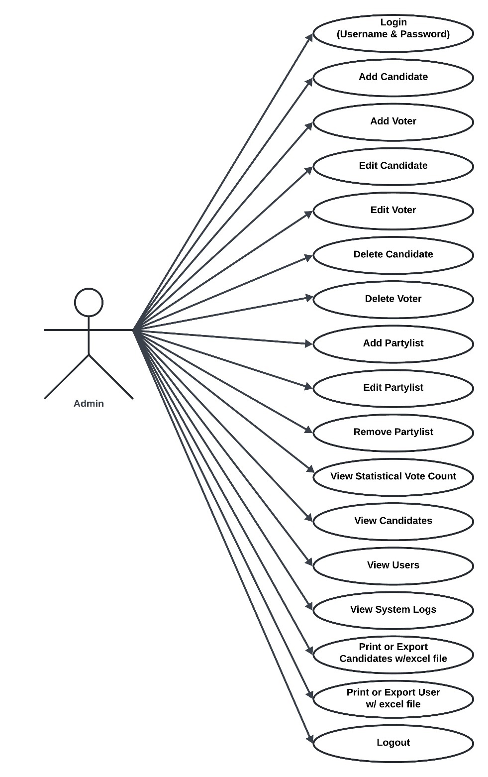

Figure 3.4 Use Case Diagram of UseP E-Votar for Admin/Staff User

Figure 3.4shows the interaction between the admin/staff user and the system. This shows how admin/staff utilizes the system. Similarly, it displays the different features and functionalities that an admin/staff can access and manage within the system.

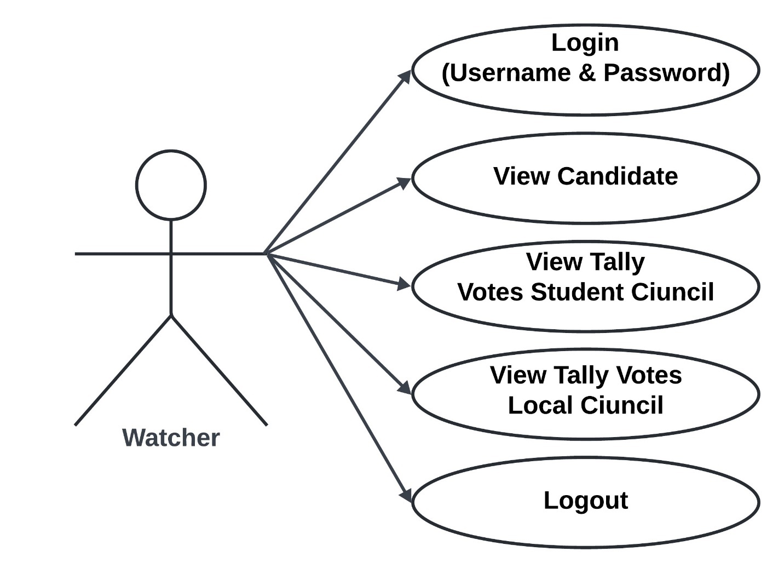

Figure 3.5 Use Case Diagram of UseP E-Votar for Watcher User

Figure 3.5shows the interaction between the watcher user and the system. This shows how the watcher utilizes the system. Similarly, it displays the different features and functionalities that a watcher can access and manage within the system.

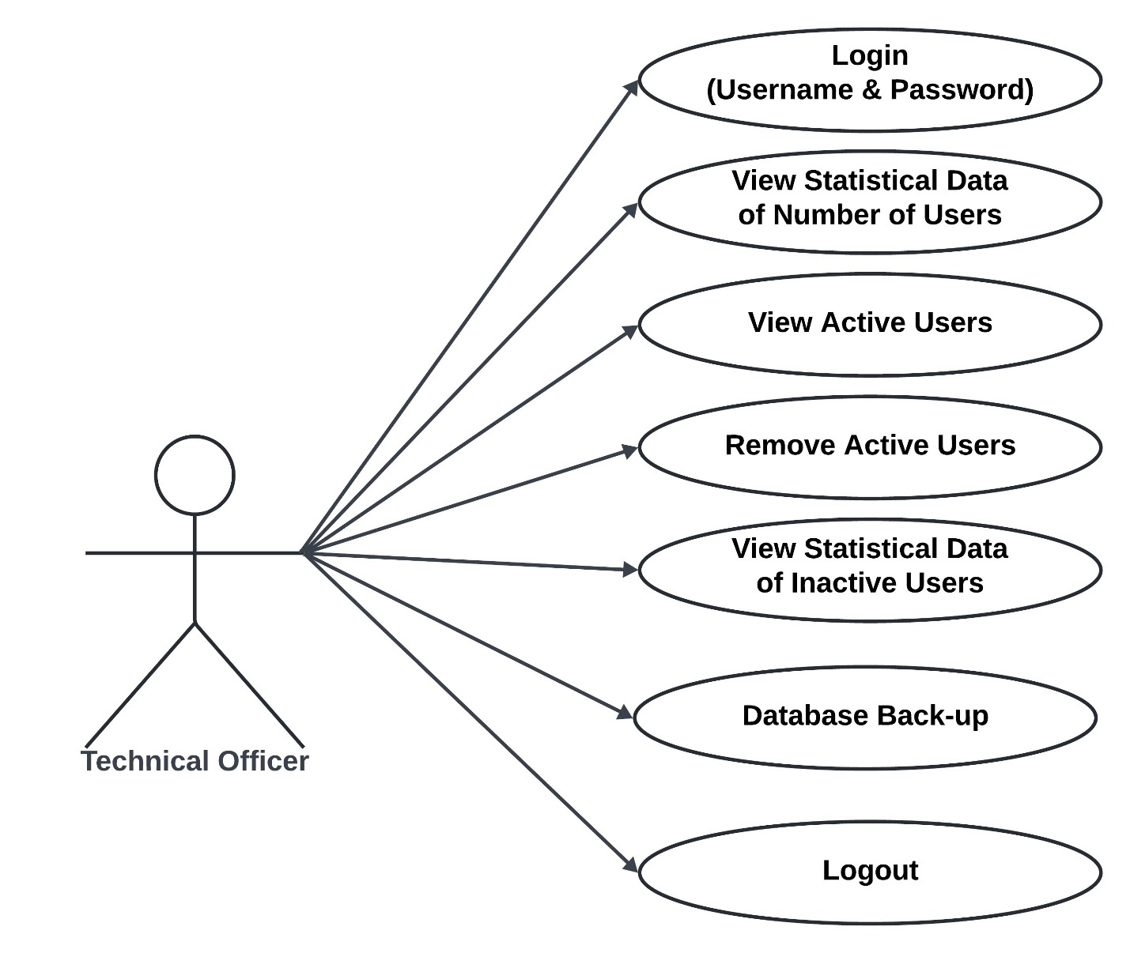

Figure 3.6 Use Case Diagram of UseP E-Votar for Technical Officer User

Figure 3.6 shows the interaction between the technical officer user and the system. This shows how technical officers utilize the system. Similarly, it displays the different features and functionalities that a technical officer can access and manage within the system.

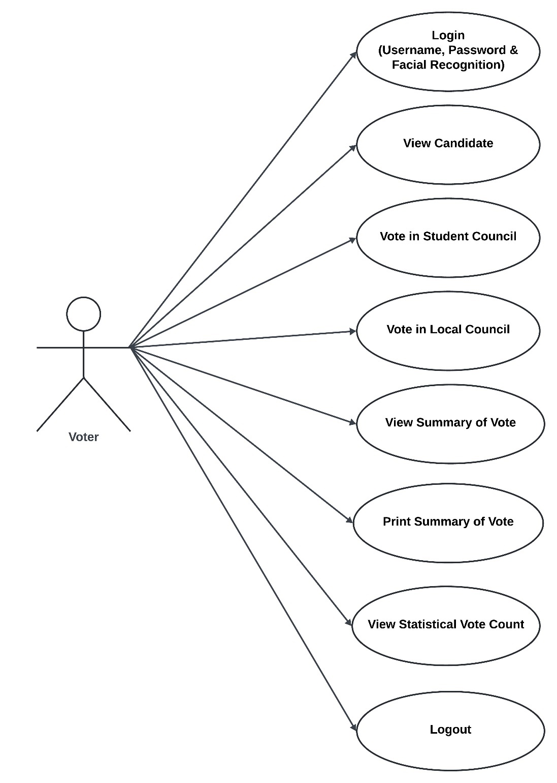

Figure 3.7 Use Case Diagram of UseP E-Votar for Voter User

Figure 3.7shows the interaction between the voter user and the system. This shows how voters utilize the system. Similarly, it displays the different features and functionalities that a voter can access and manage within the system.

## Use Case Description

This section contains the specification of the use cases of this project. These were made to know the different conditions and requirements of the system’s entirety.

**Table 3.2** Login Use Case Description

|  |  |  |
| --- | --- | --- |
| **Use Case Name:** | **Login** | |
| Scenario: | The superadmin, admin, voter, watcher, or technical officer will enter their username, password and facial recognition. | |
| Triggering Event: | After the superadmin, admin, voter, watcher, or technical officer clicks the login button. | |
| Brief Description: | The landing page of e-votar will have a log in button and will require each user to input their credentials before accessing the system. | |
| Actors: | Superadmin, Admin, Voter, Watcher, Technical Officer | |
| Related User: |  | |
| Case: |  | |
| Stakeholders: | Superadmin, Admin, Voter, Watcher, and Technical Officer: To input the credentials needed. | |
| Preconditions: | Access the e-votar using web browser. | |
| Post-conditions: | The system will verify the data and if access is granted, the superadmin, admin, voter, watcher, or technical officer can now view the system’s content. | |
| Flow of activities: | **Superadmin/ Admin/ Voter/ Watcher/ Technical Officer** | **System** |
| 1. Superadmin, admin, voter, watcher, or technical officer access the e-votar using a web browser and input username, password and facial recognition. | System verifies the credentials and displays the system content. |
| 2. Superadmin, admin, voter, watcher, or technical officer can now access the system. |  |

Table 3.2 Shows the use case with a scenario of the superadmin, admin, voter, watcher, or technical officer logging in to the system. The triggering event, brief description, actors, stakeholders, preconditions, post-conditions, and its flows of activities are presented further in the table.

**Table 3.3** Forget Password Use Case Description

|  |  |  |
| --- | --- | --- |
| **Use Case Name:** | **Forget Password** | |
| Scenario: | The superadmin, admin, voter, watcher, or technical officer wants to change the password. | |
| Triggering Event: | After the superadmin, admin, voter, watcher, or technical officer clicks the forget password button. | |
| Brief Description: | The system will identify the user who wants to change the password. | |
| Actors: | Superadmin, Admin, Voter, Watcher, Technical Officer | |
| Related User: |  | |
| Case: |  | |
| Stakeholders: | Superadmin, Admin, Voter, Watcher, and Technical Officer: To change the password. | |
| Preconditions: | Click the forgot password button. | |
| Post-conditions: | The system will identify the user who wants to change the password. | |
| Flow of activities: | **Superadmin/ Admin/ Voter/ Watcher/ Technical Officer** | **System** |
| 1. Superadmin, admin, voter, watcher, or technical officer input the email to identify the user who wants to change password. | Systems will identify the user who wants to change password. |
|  |  |

Table 3.3 shows the use case with a scenario of the superadmin, admin, voter, watcher, or technical officer changing the account password. The triggering event, brief description, actors, stakeholders, preconditions, postconditions and its flow of activities are presented further in the table.

**Table 3.4** OTP Use Case Description

|  |  |  |
| --- | --- | --- |
| **Use Case Name:** | **Forget Password** | |
| Scenario: | The superadmin, admin, voter, watcher, or technical officer wants to change the password. | |
| Triggering Event: | After the superadmin, admin, voter, watcher, or technical officer clicks the forget password button. | |
| Brief Description: | The system will identify the user who wants to change the password. | |
| Actors: | Superadmin, Admin, Voter, Watcher, Technical Officer | |
| Related User: |  | |
| Case: |  | |
| Stakeholders: | Superadmin, Admin, Voter, Watcher, and Technical Officer: To change the password. | |
| Preconditions: | Click the forgot password button. | |
| Post-conditions: | The system will identify the user who wants to change the password. | |
| Flow of activities: | **Superadmin/ Admin/ Voter/ Watcher/ Technical Officer** | **System** |
| 1. Superadmin, admin, voter, watcher, or technical officer input the email to identify the user who wants to change password. | Systems will identify the user who wants to change password. |
|  |  |

Table 3.4 shows the use case with a scenario of the superadmin, admin, voter, watcher, or technical officer submitting the OTP to the system. The triggering event, brief description, actors, stakeholders, preconditions, postconditions and its flow of activities are presented further in the table.

**Table 3.5** Start Election Period Use Case Description

|  |  |  |
| --- | --- | --- |
| **Use Case Name:** | **Start Election Period** | |
| Scenario: | The superadmin wants to start the election period. | |
| Triggering Event: | After the superadmin sets the date and clicks the start button. | |
| Brief Description: | The voting period will officially start where USeP Tagum unit students can cast their votes. | |
| Actors: | Superadmin | |
| Related User: |  | |
| Case: |  | |
| Stakeholders: | Superadmin: To start the election period and voters can cast their votes. | |
| Preconditions: | Logged in as admin and set the election period. | |
| Post-conditions: | The system will start the election period and voters can cast their votes. | |
| Flow of activities: | **Superadmin** | **System** |
| 1. Superadmin set the date of the election period and clicks the start button. | The system will start the election period and eligible voters will be able to cast their votes. |
|  |  |

Table 3.5 shows the use case with a scenario of the superadmin starting the election period. The triggering event, brief description, actors, stakeholders, preconditions, postconditions and its flow of activities are presented further in the table.

**Table 3.6** Close Election Period Use Case Description

|  |  |  |
| --- | --- | --- |
| **Use Case Name:** | **Close Election Period** | |
| Scenario: | The superadmin wants to close the election period. | |
| Triggering Event: | After the superadmin clicks the close button. | |
| Brief Description: | The voting process will officially close where USeP Tagum unit students can no longer cast their votes. | |
| Actors: | Superadmin | |
| Related User: |  | |
| Case: |  | |
| Stakeholders: | Superadmin: To close the election period. | |
| Preconditions: | Logged in as superadmin. | |
| Post-conditions: | The system will close the election period and voters can no longer cast their votes. | |
| Flow of activities: | **Superadmin** | **System** |
| 1.Superadmin close the election period | The system closes the election period. |
|  |  |

Table 3.6 shows the use case with a scenario of the superadmin closing the election period. The triggering event, brief description, actors, stakeholders, preconditions, post-conditions, and its flows of activities are presented further in the table.

**Table 3.7** View Statistical Vote Count Use Case Description

|  |  |  |
| --- | --- | --- |
| **Use Case Name:** | **View Statistical Vote Count** | |
| Scenario: | The superadmin, admin, or voter want to view the statistical vote count. | |
| Triggering Event: | After the superadmin, admin click the view statistic button. | |
| Brief Description: | The vote count will be gathered, and superadmin, admins, and voters can statistically view the results. | |
| Actors: | Superadmin, Admin, Voter | |
| Related User: |  | |
| Case: |  | |
| Stakeholders: | Superadmin, admin, and voter: To view the statistical vote count of each candidate. | |
| Preconditions: | Click the view statistic button. | |
| Post-conditions: | Display the total number of votes and percentage garnered by each candidate. | |
| Flow of activities: | **Superadmin** | **System** |
| 1. Superadmin, admin, or voter click the view statistic button | The system will allow the superadmin, admin, or voter to proceed to view the statistical count and display the overall numbers and percentage of votes for each candidate. |
|  |  |

Table 3.7 shows the use case with a scenario of the superadmin, admin, voter viewing the statistical vote count. The triggering event, brief description, actors, stakeholders, preconditions, post-conditions, and its flows of activities are presented further in the table.

**Table 3.8** View Candidates Use Case Description

|  |  |  |
| --- | --- | --- |
| **Use Case Name:** | **View Candidates** | |
| Scenario: | Superadmin, admin, voter, or watcher want to view the candidates of the election. | |
| Triggering Event: | After the superadmin, admin, voter, or watcher click the view candidates button. | |
| Brief Description: | The superadmin, admin, voter, or watcher can view the election candidates and view their detailed information such as candidates’ profile and campaign platforms within the system. | |
| Actors: | Superadmin, Admin, Voter, Watcher | |
| Related User: |  | |
| Case: |  | |
| Stakeholders: | Superadmin, Admin, Voter, Watcher: To view the candidates of the election. | |
| Preconditions: | Click the view candidate button. | |
| Post-conditions: | The system will display all the categorized candidates of the ongoing election. | |
| Flow of activities: | **Superadmin/ Admin/ Voter/ Watcher** | **System** |
| 1. Superadmin, admin, voter, or watcher clicks the view candidate button | The system will display all the categorized candidates of the election. |
|  |  |

Table 3.8 Shows the use case with a scenario of the superadmin, admin, voter, or watcher viewing the election candidate. The triggering event, brief description, actors, stakeholders, preconditions, post-conditions, and its flows of activities are presented further in the table.

**Table 3.9** View Users Use Case Description

|  |  |  |
| --- | --- | --- |
| **Use Case Name:** | **View Users** | |
| Scenario: | Superadmin/ admin want to view the users. | |
| Triggering Event: | After superadmin/ admin click the view user button. | |
| Brief Description: | The superadmin/admin can view the users of the e-votar. | |
| Actors: | Superadmin, Admin | |
| Related User: |  | |
| Case: |  | |
| Stakeholders: | Superadmin, Admin: To view the users of the system. | |
| Preconditions: | Logged in as Superadmin/admin and clicked the view user button. | |
| Post-conditions: | Superadmin/Admin can successfully view the users of the e-votar. | |
| Flow of activities: | **Superadmin/Admin** | **System** |
| 1. The superadmin/ Admin click the view users button | The system will display the users of e-votar. |
|  |  |

Table 3.9 shows the use case with a scenario of the superadmin/admin viewing the users of e-votar. The triggering event, brief description, actors, stakeholders, preconditions, post-conditions, and its flows of activities are presented further in the table.

**Table 3.10** View System Logs Use Case Description

|  |  |  |
| --- | --- | --- |
| **Use Case Name:** | **View System Logs** | |
| Scenario: | The superadmin/admin will view the system logs. | |
| Triggering Event: | After the superadmin or admin clicks the view system logs button. | |
| Brief Description: | The superadmin/admin can access and review detailed information about the system logs. These logs contain essential data related to system events, errors and activities. | |
| Actors: | Superadmin, Admin | |
| Related User: |  | |
| Case: |  | |
| Stakeholders: | Superadmin/ Admin: To view the system logs. | |
| Preconditions: | Logged in as superadmin/admin | |
| Post-conditions: | The system will display detailed log entries, including timestamps, event descriptions, and severity levels. | |
| Flow of activities: | **Superadmin/Admin** | **System** |
| 1. The superadmin/ admin clicks the system logs button. | The system provides a list of logs, organized by date and event type. |
|  |  |

Table 3.10 shows the use case with a scenario of the superadmin/admin reviewing the detailed information of system logs. The triggering event, brief description, actors, stakeholders, preconditions, post-conditions, and its flows of activities are presented further in the table.

**Table 3.11** Print/Export Candidates Use Case Description

|  |  |  |
| --- | --- | --- |
| **Use Case Name:** | **Print or Export Candidates** | |
| Scenario: | The superadmin, admin or voter wants to print or export candidate’s information using an excel file. | |
| Triggering Event: | After the superadmin, admin or voter click the print or export candidates button | |
| Brief Description: | The superadmin, admin or voter can print or export a list of candidates with excel in the system. | |
| Actors: | Superadmin, Admin, Voter | |
| Related User: |  | |
| Case: |  | |
| Stakeholders: | Superadmin, Admin, Voter: To print or export list of candidates using an excel file. | |
| Preconditions: | Click the print or export candidates button. | |
| Post-conditions: | Superadmin, admin or voter can now have the printable view of list of candidates or receive a downloadable excel file containing candidates list. | |
| Flow of activities: | **Superadmin/Admin/Voter** | **System** |
| 1. Superadmin, admin or voter click the print or export candidates button | The System will generate a printable view of list of candidates or create a downloadable excel file containing candidates' data. |
|  |  |

Table 3.11 shows the use case with a scenario of the superadmin, admin, or voter printing or exporting a list of candidates from the system. The triggering event, brief description, actors, stakeholders, preconditions, post-conditions, and its flows of activities are presented further in the table.

**Table 3.12** Print/Export User Use Case Description

|  |  |  |
| --- | --- | --- |
| **Use Case Name:** | **Print or Export User** | |
| Scenario: | The superadmin, admin, or voter wants to print/export user. | |
| Triggering Event: | After superadmin, admin, or voter clicks the print/export user button. | |
| Brief Description: | The superadmin, admin or voter can print or export user information with excel in the system. | |
| Actors: | Superadmin, Admin, Voter | |
| Related User: |  | |
| Case: |  | |
| Stakeholders: | Superadmin, Admin, Voter: To print or export user information using an excel file. | |
| Preconditions: | Click the print or export user button. | |
| Post-conditions: | Superadmin, admin or voter can now have the printable view of user information or receive a downloadable excel file containing user data. | |
| Flow of activities: | **Superadmin/ Admin/ Voter** | **System** |
| 1. Superadmin, admin or voter click the print or export user button | The System will generate a printable view of user information or create a downloadable excel file containing user data. |
|  |  |

Table 3.12 shows the use case with a scenario of the superadmin, admin, or voter prints or exports candidate data from the system. The triggering event, brief description, actors, stakeholders, preconditions, post-conditions, and its flows of activities are presented further in the table.

**Table 3.13** Print/Export Election Result Use Case Description

|  |  |  |
| --- | --- | --- |
| **Use Case Name:** | **Print/Export Election Result** | |
| Scenario: | The superadmin, admin, or voter wants to print/export election. | |
| Triggering Event: | After superadmin, admin, or voter clicks the print/export election button. | |
| Brief Description: | The superadmin, admin or voter can print or export election information with excel in the system. | |
| Actors: | Superadmin, Admin, Voter | |
| Related User: |  | |
| Case: |  | |
| Stakeholders: | Superadmin, Admin, Voter: To print or export election information using an excel file. | |
| Preconditions: | Click the print or export election button. | |
| Post-conditions: | Superadmin, admin or voter can now have the printable view of list of candidates or receive a downloadable excel file containing candidates list. | |
| Flow of activities: | **Superadmin/Admin/Voter** | **System** |
| 1. Superadmin, admin or voter click the print or export election button | The System will generate a printable view of election information or create a downloadable excel file containing election data. |
|  |  |

Table 3.13 shows the use case with a scenario of the superadmin, admin, or voter prints or exports election data from the system. The triggering event, brief description, actors, stakeholders, preconditions, post-conditions, and its flows of activities are presented further in the table.

**Table 3.14** Add/Edit Admin as Use Case Description

|  |  |  |
| --- | --- | --- |
| **Use Case Name:** | **Add/Edit Admin** | |
| Scenario: | The superadmin wants to add or edit an admin user account. | |
| Triggering Event: | After superadmin clicks the add or edit admin button. | |
| Brief Description: | The Superadmin inputs the necessary details for creating or modifying an admin user account. | |
| Actors: | Superadmin | |
| Related User: |  | |
| Case: |  | |
| Stakeholders: | Superadmin: To add or edit an admin user account. | |
| Preconditions: | Logged in as a superadmin. | |
| Post-conditions: | The system will add a new admin or update the existing admin user account. | |
| Flow of activities: | **Admin** | **System** |
| 1. The superadmin clicks the add or edit admin button. | The system prompts the superadmin to input relevant details to add or edit the admin account. |
| 2. The superadmin provides the necessary information for admin. | The system validates the input and successfully adds a new admin or updates the existing admin user account. |

Table 3.14 shows the use case with a scenario of the superadmin adding a new admin or editing an existing admin account in the system. The triggering event, brief description, actors, stakeholders, preconditions, post-conditions, and its flows of activities are presented further in the table.

**Table 3.15** Delete Admin Use Case Description

|  |  |  |
| --- | --- | --- |
| **Use Case Name:** | **Delete Admin** | |
| Scenario: | Superadmin wants to delete the admin account. | |
| Triggering Event: | After superadmin click the delete admin button. | |
| Brief Description: | Admin accounts will be gathered in the admin accounts tab and can be deleted by the superadmin. | |
| Actors: | Superadmin | |
| Related User: |  | |
| Case: |  | |
| Stakeholders: | Superadmin: To delete an existing admin account. | |
| Preconditions: | Logged in as superadmin and the admin account exists. | |
| Post-conditions: | The admin account is deleted and no longer accessible. | |
| Flow of activities: | **Superadmin** | **System** |
| 1. The superadmin navigates the admin account then selects a specific admin account and clicks the delete admin button. | The system displays a confirmation message to the superadmin. |
| 2. The superadmin confirmed the deletion. | The system deactivates the admin’s account and removes any personal data associated with the deleted account. |

Table 3.15 shows the use case with a scenario of the Superadmin deleting an existing admin account in the system. The triggering event, brief description, actors, stakeholders, preconditions, post-conditions, and its flows of activities are presented further in the table.

**Table 3.16** View Student Council Election Result Use Case Description

|  |  |  |
| --- | --- | --- |
| **Use Case Name:** | **View Student Council Election Result** | |
| Scenario: | The superadmin wants to view the student council election result. | |
| Triggering Event: | After the superadmin navigates the student council election result in the dashboard page. | |
| Brief Description: | The results of the student council election will be gathered in the student council election tab where superadmin can view the name of the candidates, their respective positions and vote counts. | |
| Actors: | Superadmin | |
| Related User: |  | |
| Case: |  | |
| Stakeholders: | Superadmin: To view the result of student council election. | |
| Preconditions: | Logged in as superadmin and if the student council is completed. | |
| Post-conditions: | The system displays information about the result of the student council election. | |
| Flow of activities: | **Superadmin** | **System** |
| 1. The superadmin navigates the student councilelection results section on the dashboard page. | The system displays the detailed result of the student council election. |
|  |  |

Table 3.16 shows the use case with a scenario of the superadmin viewing the student council election result in the system. The triggering event, brief description, actors, stakeholders, preconditions, post-conditions, and its flows of activities are presented further in the table.

**Table 3.17** View Local Council Election Result Use Case Description

|  |  |  |
| --- | --- | --- |
| **Use Case Name:** | **View Local Council Election Result** | |
| Scenario: | The superadmin wants to view the local council election result. | |
| Triggering Event: | After the superadmin navigates the local council election result in the dashboard page. | |
| Brief Description: | The results of the local council election will be gathered in the local council election tab where superadmin can view the name of the candidates, their respective positions and vote counts. | |
| Actors: | Superadmin | |
| Related User: |  | |
| Case: |  | |
| Stakeholders: | Superadmin: To view the result of student council election. | |
| Preconditions: | Logged in as superadmin and if the local council is completed. | |
| Post-conditions: | The system displays information about the result of the student council election. | |
| Flow of activities: | **Superadmin** | **System** |
| 1. The superadmin navigates the local council election results section on the dashboard page. | The system displays the detailed result of the student council election. |
|  |  |

Table 3.17 shows the use case with a scenario of the superadmin viewing the local council election result in the system. The triggering event, brief description, actors, stakeholders, preconditions, post-conditions, and its flows of activities are presented further in the table.

**Table 3.18** Add/Edit Candidate Use Case Description

|  |  |  |
| --- | --- | --- |
| **Use Case Name:** | **Add/Edit Candidate** | |
| Scenario: | The admin wants to add or edit a candidate account. | |
| Triggering Event: | After admin clicks the add or edit candidate button. | |
| Brief Description: | After admin clicks the add or edit candidate button. | |
| Actors: | Admin | |
| Related User: |  | |
| Case: |  | |
| Stakeholders: | Admin: To add or edit a candidate account. | |
| Preconditions: | Logged in as an admin. | |
| Post-conditions: | The system will add a new candidate or update the existing candidate account. | |
| Flow of activities: | **Admin** | **System** |
| 1. The admin clicks the add or edit candidate button. | The system prompts the admin to input relevant details to add or edit the candidate account. |
| 2. The admin provides the necessary information for the candidate. | The system validates the input and successfully adds a new candidate or updates the existing admin user account. |

Table 3.18 shows the use case with a scenario of the admin adding a new candidate or editing an existing candidate account in the system. The triggering event, brief description, actors, stakeholders, preconditions, post-conditions, and its flows of activities are presented further in the table.

**Table 3.19** Delete Candidate Use Case Description

|  |  |  |
| --- | --- | --- |
| **Use Case Name:** | **Delete Candidate** | |
| Scenario: | Admin wants to delete the candidate’s account. | |
| Triggering Event: | After admin clicks the delete candidate button. | |
| Brief Description: | Candidate accounts will be gathered in the candidate accounts tab and can be deleted by the admin. | |
| Actors: | Admin | |
| Related User: |  | |
| Case: |  | |
| Stakeholders: | Admin: To delete an existing candidate account. | |
| Preconditions: | Logged in as admin and the candidate account exists. | |
| Post-conditions: | The candidate account is deleted and no longer accessible. | |
| Flow of activities: | **Superadmin** | **System** |
| 1. The superadmin navigates the candidate account then selects a specific candidate account and clicks the delete candidate button. | The system displays a confirmation message to the admin. |
| 2. The admin confirmed the deletion. | The system deactivates the candidate’s account and removes any personal data associated with the account. |

Table 3.19 shows the use case with a scenario of the admin deleting an existing candidate account in the system. The triggering event, brief description, actors, stakeholders, preconditions, post-conditions, and its flows of activities are presented further in the table.

**Table 3.20** Add/Edit Voter Use Case Description

|  |  |  |
| --- | --- | --- |
| **Use Case Name:** | **Add/Edit Voter** | |
| Scenario: | The admin wants to add or edit a voter account. | |
| Triggering Event: | After admin clicks the add or edit voter button. | |
| Brief Description: | The admin inputs the necessary details for creating or modifying a voter account. | |
| Actors: | Admin | |
| Related User: |  | |
| Case: |  | |
| Stakeholders: | Admin: To add or edit a voter account. | |
| Preconditions: | Logged in as an admin. | |
| Post-conditions: | The system will add a new voter or update the existing voter account. | |
| Flow of activities: | **Admin** | **System** |
| 1. The admin clicks the add or edit voter button. | The system prompts the admin to input relevant details to add or edit the voter account. |
| 2. The admin provides the necessary information for the voter. | The system validates the input and successfully adds a new voter or updates the existing voter account. |

Table 3.20 shows the use case with a scenario of the admin adding a new voter or editing an existing voting account in the system. The triggering event, brief description, actors, stakeholders, preconditions, post-conditions, and its flows of activities are presented further in the table.

**Table 3.21** Delete Voter Use Case Description

|  |  |  |
| --- | --- | --- |
| **Use Case Name:** | **Delete Voter** | |
| Scenario: | Admin wants to delete the voter’s account. | |
| Triggering Event: | After admin clicks the delete voter button. | |
| Brief Description: | Voter accounts will be gathered in the voter accounts tab and can be deleted by the admin. | |
| Actors: | Admin | |
| Related User: |  | |
| Case: |  | |
| Stakeholders: | Admin: To delete an existing voter account. | |
| Preconditions: | Logged in as admin and the voter account exists. | |
| Post-conditions: | The voter account is deleted and no longer accessible. | |
| Flow of activities: | **Admin** | **System** |
| 1. The superadmin navigates the voter’s account then selects a specific voter account and clicks the delete candidate button. | The system displays a confirmation message to the admin. |
| 2. The admin confirmed the deletion. | The system deactivates the voter’s account and removes any personal data associated with the account. |

Table 3.21 shows the use case with a scenario of the admin deleting an existing voter’s account in the system. The triggering event, brief description, actors, stakeholders, preconditions, post-conditions, and its flows of activities are presented further in the table.

**Table 3.22** Add/Edit Partylist Use Case Description

|  |  |  |
| --- | --- | --- |
| **Use Case Name:** | **Add/Edit Partylist** | |
| Scenario: | The admin wants to add or edit a partylist. | |
| Triggering Event: | After admin clicks the add or edit partylist. | |
| Brief Description: | The admin inputs the necessary details for creating or modifying a partylist. | |
| Actors: | Admin | |
| Related User: |  | |
| Case: |  | |
| Stakeholders: | Admin: To add or edit a partylist. | |
| Preconditions: | Logged in as an admin. | |
| Post-conditions: | The system will add a new partylist or update the partylist. | |
| Flow of activities: | **Admin** | **System** |
| 1. The admin clicks the add or edit partylist button. | The system prompts the admin to input relevant details to add or edit the partylist. |
| 2. The admin provides the necessary information for the partylist. | The system validates the input and successfully adds a new partylist or updates the existing partylist. |

Table 3.22 shows the use case with a scenario of the admin adding a new partylist or editing an existing partylist in the system. The triggering event, brief description, actors, stakeholders, preconditions, post-conditions, and its flows of activities are presented further in the table.

**Table 3.23** Remove Partylist Use Case Description

|  |  |  |
| --- | --- | --- |
| **Use Case Name:** | **Remove Partylist** | |
| Scenario: | Admin wants to remove partylist. | |
| Triggering Event: | After admin clicks the remove partylist button. | |
| Brief Description: | Partylist will be gathered in the partylist tab and can be removed by the admin. | |
| Actors: | Admin | |
| Related User: |  | |
| Case: |  | |
| Stakeholders: | Admin: To remove an existing partylist. | |
| Preconditions: | Logged in as admin and the partylist exists. | |
| Post-conditions: | The partylist is deleted. | |
| Flow of activities: | **Admin** | **System** |
| 1. The admin navigates the partylist then selects a specific partylist and clicks the remove partylist button. | The system displays a confirmation message to the admin. |
| 2. The admin confirmed the deletion. | The system removes the partylist. |

Table 3.23 shows the use case with a scenario of the admin removing an existing partylist in the system. The triggering event, brief description, actors, stakeholders, preconditions, post-conditions, and its flows of activities are presented further in the table.

**Table 3.24** Vote in Student Council Use Case Description

|  |  |  |
| --- | --- | --- |
| **Use Case Name:** | **Vote in Student Council** | |
| Scenario: | The voter wants to vote in the student council election. | |
| Triggering Event: | After the user clicks the vote student council button. | |
| Brief Description: | The system will display the list of student council candidates, along with their respective positions, and then the voter can choose their preferred candidate. | |
| Actors: | Voter | |
| Related User: |  | |
| Case: |  | |
| Stakeholders: | Voter: To vote in the student council election. | |
| Preconditions: | The voter is currently logged in to the system, and the student election is still ongoing. | |
| Post-conditions: | Voter’s vote successfully cast in the student council election. | |
| Flow of activities: | **Voter** | **System** |
| 1. The voter clicks the vote student council button. | The system displays the list of candidates and their respective positions. |
| 2. Voter selects a candidate | The system records the vote and prevents the voter from voting again |

Table 3.24 shows the use case with a scenario of the voter votes in student council election in the system. The triggering event, brief description, actors, stakeholders, preconditions, post-conditions, and its flows of activities are presented further in the table.

**Table 3.25** Vote in Local Council Use Case Description

|  |  |  |
| --- | --- | --- |
| **Use Case Name:** | **Vote in Local Council** | |
| Scenario: | The voter wants to vote in the local council election. | |
| Triggering Event: | After the user clicks the proceed to local council button. | |
| Brief Description: | The system will display the list of local council candidates, along with their respective positions, and then the voter can choose their preferred candidate. | |
| Actors: | Voter | |
| Related User: |  | |
| Case: |  | |
| Stakeholders: | Voter: To vote in the local council election. | |
| Preconditions: | The voter is currently logged in to the system, and the student election is still ongoing. | |
| Post-conditions: | Voter’s vote successfully cast in the local council election. | |
| Flow of activities: | **Voter** | **System** |
| 1. The voter clicks the vote student council button. | The system displays the list of candidates and their respective positions. |
| 2. Voter selects a candidate | The system records the vote and prevents the voter from voting again |

Table 3.25 shows the use case with a scenario of the voter votes in local council election in the system. The triggering event, brief description, actors, stakeholders, preconditions, post-conditions, and its flows of activities are presented further in the table.

**Table 3.26** View Vote Summary Use Case Description

|  |  |  |
| --- | --- | --- |
| **Use Case Name:** | **View Vote Summary** | |
| Scenario: | The voter wants to view the summary of their chosen candidate. | |
| Triggering Event: | After the voter submitted the vote and clicks the view summary button. | |
| Brief Description: | Voters can review the details about their chosen candidate. | |
| Actors: | Voter | |
| Related User: |  | |
| Case: |  | |
| Stakeholders: | Voter: To view the vote summary. | |
| Preconditions: | The voter has successfully submitted their vote. | |
| Post-conditions: | The system displays the vote summary. | |
| Flow of activities: | **Voter** | **System** |
| 1. The voter submitted their votes and clicked the view summary button. | The system displays the name and the position of the candidate they voted for. |
|  |  |

Table 3.26 shows the use case with a scenario of the voter viewing the summary of their vote in the election. The triggering event, brief description, actors, stakeholders, preconditions, post-conditions, and its flows of activities are presented further in the table.

**Table 3.27** View Tally Votes in Student Council Use Case Description

|  |  |  |
| --- | --- | --- |
| **Use Case Name:** | **View Tally Votes in Student Council** | |
| Scenario: | The watcher wants to view the tally of votes in the student council election. | |
| Triggering Event: | After the watcher logs in to the system and clicks see more in the student council tally vote section in the dashboard. | |
| Brief Description: | The watcher can view the real time tally updates, including the total votes received by each student council candidate for various positions. This allows watcher able to monitor the election progress. | |
| Actors: | Watcher | |
| Related User: |  | |
| Case: |  | |
| Stakeholders: | Watcher: To view the tally votes in student council election | |
| Preconditions: | Logged in as watcher | |
| Post-conditions: | The watcher has reviewed the vote tally and can monitor the student council election progress. | |
| Flow of activities: | **Watcher** | **System** |
| 1. The watcher logs in to the system and clicks see more. | The system displays the real time tally updates, including the total votes received by each candidate of student council for various positions. |
|  |  |

Table 3.27 shows the use case with a scenario of the watcher viewing the tally votes in student council in the system. The triggering event, brief description, actors, stakeholders, preconditions, post-conditions, and its flows of activities are presented further in the table.

**Table 3.28** View Tally Votes in Local Council Use Case Description

|  |  |  |
| --- | --- | --- |
| **Use Case Name:** | **View Tally Votes in Local Council** | |
| Scenario: | The watcher wants to view the tally of votes in the local council election. | |
| Triggering Event: | After the watcher logs in to the system and clicks see more in the local council tally vote section in the dashboard. | |
| Brief Description: | The watcher can view the real time tally updates, including the total votes received by each local council candidate for various positions. This allows watcher able to monitor the election progress. | |
| Actors: | Watcher | |
| Related User: |  | |
| Case: |  | |
| Stakeholders: | Watcher: To view the tally votes in local council election. | |
| Preconditions: | Logged in as watcher | |
| Post-conditions: | The watcher has reviewed the vote tally and can actively monitor the student council election progress. | |
| Flow of activities: | **Watcher** | **System** |
| 1. The watcher logs in to the system and clicks see more. | The system displays the real time tally updates, including the total votes received by each candidate of local council for various positions. |
|  |  |

Table 3.28 shows the use case with a scenario of the watcher viewing the tally votes in local council in the system. The triggering event, brief description, actors, stakeholders, preconditions, post-conditions, and its flows of activities are presented further in the table.

**Table 3.29** View Statistical Data of Number of Users Use Case Description

|  |  |  |
| --- | --- | --- |
| **Use Case Name:** | **View Statistical Data of Number of Users** | |
| Scenario: | The technical office wants to view the statistical data of number of users in the system. | |
| Triggering Event: | After the technical officer access the system | |
| Brief Description: | The technical officer can view statistical data related to the number of users. | |
| Actors: | Technical Officer | |
| Related User: |  | |
| Case: |  | |
| Stakeholders: | Technical Officer: To view the statistical data of numbers of users. | |
| Preconditions: | Logged in as Technical Officer | |
| Post-conditions: | The system displays the statistical data related to the number of users. | |
| Flow of activities: | **Technical Officer** | **System** |
| 1. The technical officer accesses the system | The system displays the statistical data related to the number of users |
|  |  |

Table 3.29 shows the use case with a scenario of the technical office viewing the statistical data of number of users in the system. The triggering event, brief description, actors, stakeholders, preconditions, post-conditions, and its flows of activities are presented further in the table.

**Table 3.30** View Active Users Use Case Description

|  |  |  |
| --- | --- | --- |
| **Use Case Name:** | **View Active Users** | |
| Scenario: | The technical officer wants to view active users in the system. | |
| Triggering Event: | After the technical officer clicks the active users button. | |
| Brief Description: | The technical officer can view the active users including their roles and department. | |
| Actors: | Technical Officer | |
| Related User: |  | |
| Case: |  | |
| Stakeholders: | Technical Officer: To view active users | |
| Preconditions: | Logged in as technical officer | |
| Post-conditions: | The system displays the active user section. | |
| Flow of activities: | **Technical Officer** | **System** |
| 1. The technical officer accesses the system and clicks the active user button. | The system displays the active user section. |
|  |  |

Table 3.30 shows the use case with a scenario of the technical Officer viewing the active users in the system. The triggering event, brief description, actors, stakeholders, preconditions, post-conditions, and its flows of activities are presented further in the table.

**Table 3.31** Remove Active User Use Case Description

|  |  |  |
| --- | --- | --- |
| **Use Case Name:** | **Remove Active User** | |
| Scenario: | The technical officer wants to remove an active user. | |
| Triggering Event: | After the technical officer clicks the remove active user button. | |
| Brief Description: | The active users are gathered in the active users' section and can be removed by the technical officer. | |
| Actors: | Technical Officer | |
| Related User: | Technical Officer: To remove an active user | |
| Case: |  | |
| Stakeholders: | Technical Officer: To remove an active user | |
| Preconditions: | Logged in as technical officer. | |
| Post-conditions: | The active user is successfully removed. | |
| Flow of activities: | **Technical Officer** | **System** |
| 1. The technical officer navigates the active user then selects a specific active user and clicks the remove active user button. | The system displays a confirmation message to the technical officer. |
| 2. The admin confirmed the deletion. | The system removes the active user |

Table 3.31 shows the use case with a scenario of the technical officer removing an active user. The triggering event, brief description, actors, stakeholders, preconditions, post-conditions, and its flows of activities are presented further in the table.

**Table 3.32** View Statistical Data of Inactive Users Use Case Description

|  |  |  |
| --- | --- | --- |
| **Use Case Name:** | **View Statistical Data of Inactive Users** | |
| Scenario: | The technical officer views the statistical data of inactive users. | |
| Triggering Event: | After the technical officer accesses the system. | |
| Brief Description: | The technical officer can view the statistical data of inactive users. | |
| Actors: | Technical Officer | |
| Related User: |  | |
| Case: |  | |
| Stakeholders: | Technical Officer: To view statistical data of inactive users. | |
| Preconditions: | Logged in as technical officer. | |
| Post-conditions: | The system displays statistical data related to the inactive users. | |
| Flow of activities: | **Technical Officer** | **System** |
| 1. The technical officer accesses the syste | The system displays statistical data related to the inactive users. |
|  |  |

Table 3.32 shows the use case with a scenario of the technical officer viewing the inactive user in the system. The triggering event, brief description, actors, stakeholders, preconditions, post-conditions, and its flows of activities are presented further in the table.

## Functional Requirements

Functional requirements are a set of functionalities that developers have to incorporate into a product to enable users to accomplish their task. Presented below are the functional requirements of the system displayed in a table. Furthermore, this is a list of tasks that has been divided into sections having its priority level set depending on the highest possible value of the section. This will be utilized in making other following diagrams and in the application development itself. To fully understand the presentation, in the priority column, the corresponding terms are used:

M – Mandatory Requirements (the system must do)

D – Desirable Requirements (the system preferable should do)

O – Optional Requirements (the system may be able to)

**Table 3.33** Functional Requirements

|  |  |  |  |
| --- | --- | --- | --- |
| **No** | **Requirement** | **Requirement Description** | **Priority** |
| 1 | **e-votar_01** | **USER LOG IN**  The users can log in if the account being entered exists. | M |
| 1 | **e-votar_02** | **SUBMIT VOTE**  The users can cast their vote after logging in. | M |
| 1 | **e-votar_03** | **CREATE ACCOUNT**  The superadmin can create an account for the voters enrolled in the university | M |
| 1 | **e-votar_04** | **SCHEDULE ELECTION**  The superadmin has the authority to set the commencement and end times for the election process. | M |
| 1 | **e-votar_05** | **UPDATE SYSTEM**  The admin has the responsibility to update, add, and edit system data and functions | M |
| 1 | **e-votar_06** | **REAL TIME RESULTS**  The election watcher are able to monitor real time results. | D |
| 1 | **e-votar_07** | **REMOVE USER**  Technical Officers are able to remove users inactive user. | M |
| 1 | **e-votar_08** | **ADD USER** Admin are able to add users from current activity. | M |
| 2 | **e-votar_09** | **GENERATE REPORTS**  The system is able to generate reports for transparency. | O |

Table 3.33 describes the functional requirements of E-votar application. This contains the identified requirements of the system with their corresponding priorities. Therefore, by displaying this representation, the developers will be guided accordingly in terms of the significant sections, function, and features of the application. Likewise, the users will be able to understand the flow of the system, thus helping them accomplish their tasks.

## Non-Functional Requirements

Non-functional requirements specify the desired attribute of the entire system and its components. The following are the non-functional requirements of e-votar system:

**Performance.** The system must handle a large number of concurrent users during peak voting periods without performance degradation.

**Scalability.** The system should be able to scale horizontally to accommodate an increasing number of users and votes without compromising performance.

**Security.** The system must ensure the confidentiality, integrity, and availability of votes.

**Reliability.** The system should be highly reliable with an uptime of 99.999% during the voting period. It should include mechanisms for failover and redundancy to prevent data loss and ensure continuous operation even in case of hardware or software failures.

**Usability.** The e-votar system must be user-friendly and accessible to all voters, including those with disabilities. It should have a simple and intuitive interface and provide clear instructions.

## Activity Diagram

The Activity Diagram presents the method and the flow of the program wherein this is where users operate in the application. Moreover, this includes a graphical representation of a technique, demonstrating the progression through numerous stages as well as intermediate steps. Moreover, use an activity diagram to understand the workflow of complex algorithms. (Figure 3.8)

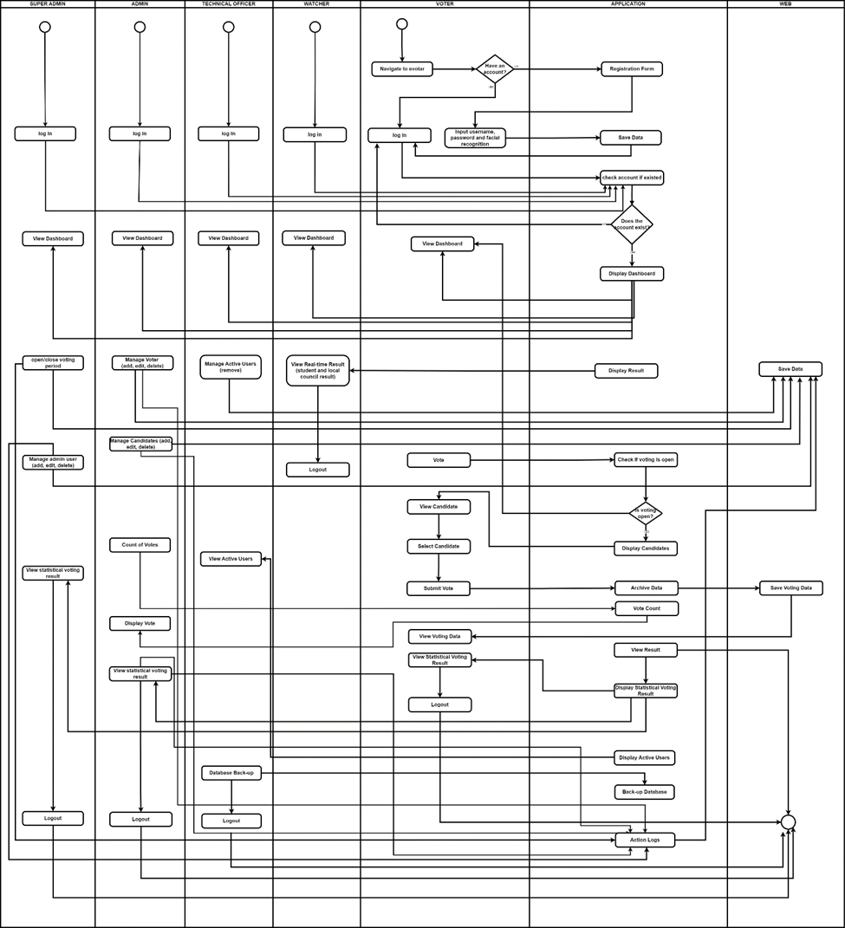

Figure 3.8 Activity Diagram of E-votar Application

Figure 3.8 illustrates the E-votar Application's processes, outlining all of the tasks that must be completed by both users and the system in order to understand each stage. To put it simply, the circles at the top represent the start of the operation. The rounded-edge rectangles depict the tasks and operations carried out by the designated parties. The arrows represent the transitions between tasks and the order of operations. The diamonds represent the decision-making processes involved in the activity. Finally, the circle at the bottom marks the end of the activity.

The users are required to log in their registered credentials to verify if their account exists. And then, a dashboard will show after successfully logging in of all the users. After that, the superadmin is able to set the commencement and end times for the election process and then the administrator is able to manage the voters (add, edit, delete) and update systems data. The users/voters are now going to proceed in view, select a candidate and then submit their votes. The user now can log out after he/she receives the confirmation that the vote has been submitted. After that the application now can also display the statistical voting result.

## System Flowchart

This section presents the system flowchart of the E-votar Application, illustrating the flow of the application from the start until the application exits. The flowchart outlines the various tasks and decision points involved, ensuring clarity and security throughout the process. It highlights the specific roles and responsibilities of different user types, including superadmin, admin, voter, watcher, and technical officer, within the application. By providing a visual representation of these interactions, the flowchart ensures that each role's tasks are clearly defined and the overall functionality of the E-votar system is transparent and well-organized. (Figure 3.9)

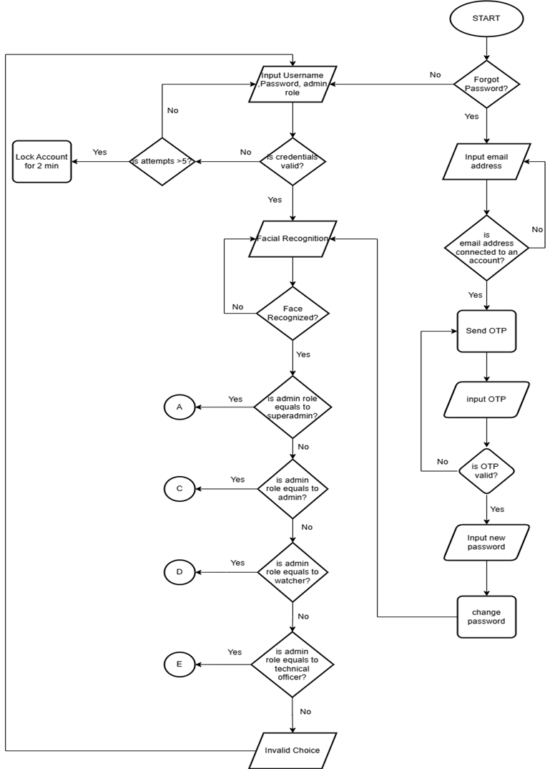

Figure 3.9 System Flowchart of E-Votar Login Administrative Users

Figure 3.9 shows how the administrative users log in the E-votar system. The flowchart illustrates the detailed steps involved from the start of the application until the user either successfully logs in or exits the application. The process begins with the user inputting their credentials. If they have forgotten their password, they have to input their email address, which the system checks to confirm it is connected to an account. If it is, an OTP (One-Time Password) is sent to their email, and the user inputs the OTP. If the OTP is valid, the user can set a new password.

For regular login, the user inputs their username, password, and selects their role. The system validates the credentials. If the credentials are invalid, the system tracks the number of attempts and locks the account for 2 minutes if there are more than five failed attempts. If the credentials are valid, the system proceeds to facial recognition. If the face is recognized, the system then checks the user's admin role. Depending on the role—superadmin, admin, watcher, or technical officer—the user is granted the appropriate permissions. If the face is not recognized or the role is invalid, the process ends or prompts for a retry. This flowchart ensures that only authorized users can log in or reset their passwords, with clearly defined roles and security measures to protect the system.

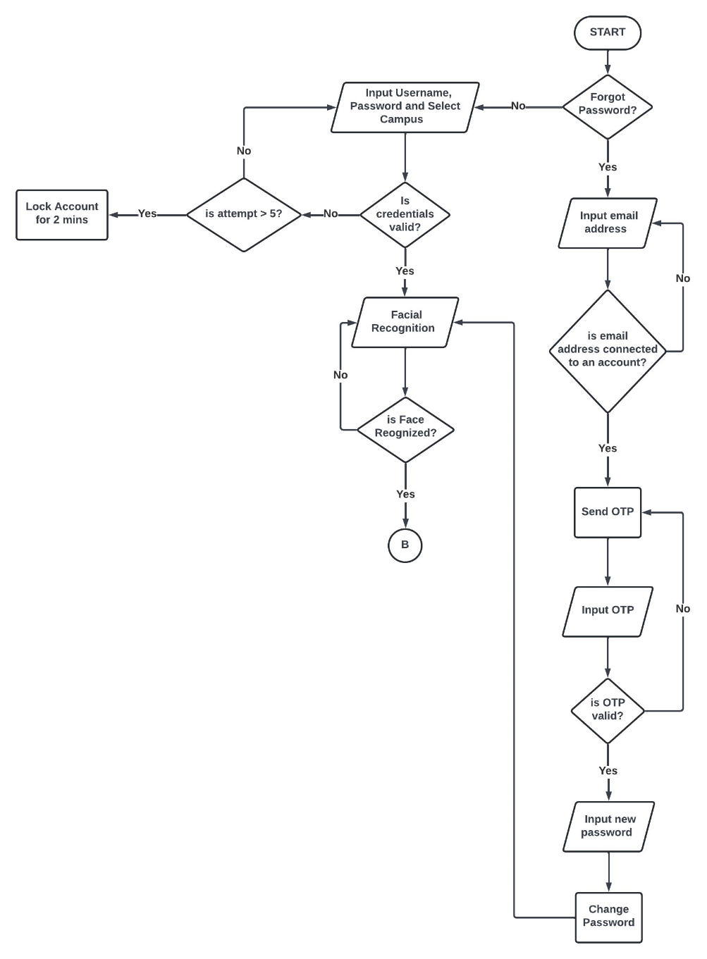

Figure 3.10 System Flowchart of E-Votar Login Voter Users

Figure 3.10 shows how voter users log in to the e-votar system. The process begins with the user starting the login sequence. If the user has forgotten their password, they can select the "Forgot Password?" option, which prompts them to input their email address. The system then checks if the email address is connected to an account. If it is, an OTP (One-Time Password) is sent to the email address. The user inputs the OTP, and if it is valid, they can input a new password to change it.

For users who have not forgotten their password, they are prompted to input their username, password, and select their campus. The system checks if the credentials are valid. If the credentials are incorrect, the system checks if the number of attempts exceeds five. If the number of attempts is greater than five, the account is locked for two minutes. If the credentials are valid, the system proceeds to facial recognition. If the face is not recognized, the user will be prompted to attempt face recognition again. If the face is recognized, the user is successfully logged in and the flow continues to the next step, labeled "B" in the diagram.

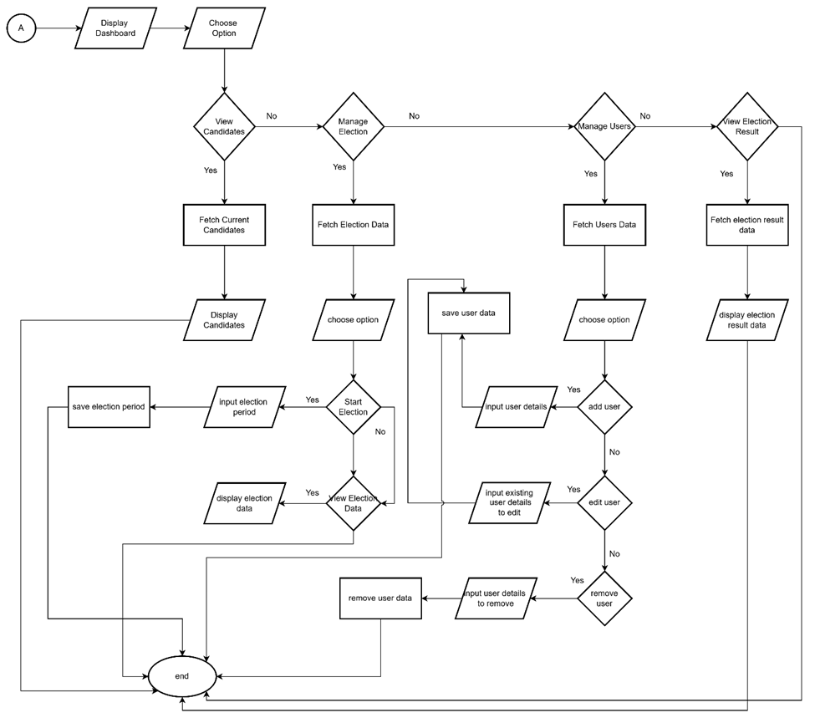

Figure 3.11 System Flowchart of E-Votar Superadmin User

Figure 3.11 shows how the superadmin user interacts with the e-votar system. After the superadmin successfully logged in, the dashboard for superadmin will then display. In the dashboard page superadmin can choose from the available options which are viewing candidates, managing elections, managing users, and viewing election results. If the superadmin selects to view candidates, the system fetches the current candidates and displays them.

If the superadmin selects to manage elections, the system fetches the election data, and the superadmin can then choose to either input the election period or start the election. If the superadmin decides to input the election period, they save the election period. If they choose to start the election, the system checks whether the election data is complete. If complete, the election starts and the data is displayed. If the superadmin opts to manage users, the system fetches user data. The superadmin can then choose to add, edit, or remove users. If adding a user, they input user details and save them. If editing a user, they input the existing user details, make the changes, and save the updated data. If removing a user, they input the user details to remove and then remove the user data. If the superadmin selects to view election results, the system fetches the election result data and displays it.

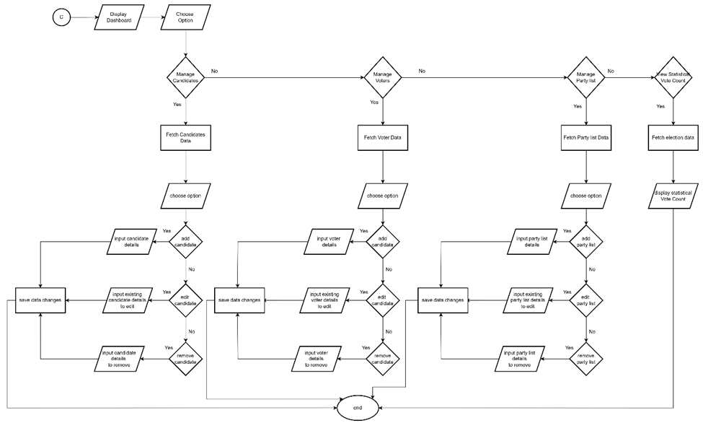

Figure 3.12 System Flowchart of E-Votar Admin/Staff User

Figure 3.12 shows how the admin/staff user interacts with the e-votar system. The process starts with displaying the dashboard, where the user chooses between managing candidates, managing voters, managing party lists, or viewing statistical vote counts. If managing candidates, voters, or party lists is selected, the system fetches the relevant data and provides options to add, edit, or remove entries. Users input details accordingly and save data changes. For viewing statistical vote counts, the system fetches and displays the election data directly. The process ensures that all changes are systematically saved before ending the interaction.

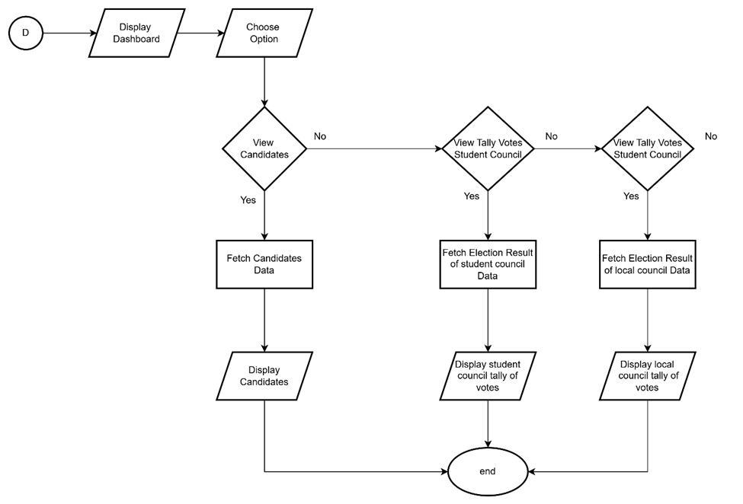

Figure 3.13 System Flowchart of E-Votar Watcher User

Figure 3.13 shows how the watcher user interacts with the e-votar system. The process begins with the user accessing the dashboard and choosing an option. The user can view candidates or tally votes for the student council or the local council. If the user selects to view candidates, the system fetches and displays the candidates' data. If the user opts to tally votes, the system fetches the election results for either the student council or the local council and displays the respective tally of votes. The process ends after the chosen information is displayed.

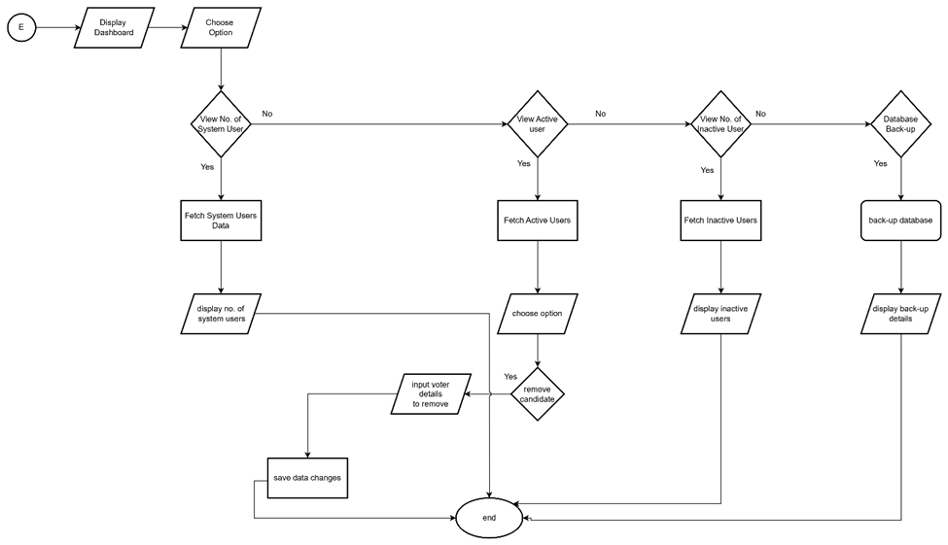

**Figure 3.14** System Flowchart of E-Votar Technical Officer User

Figure 3.14 shows how the technical officer user interacts with the e-votar system. The process begins with the user accessing the dashboard and choosing an option. The technical officer can view the number of system users, view active users, view inactive users, or perform a database backup. If the officer opts to view the number of system users, the system fetches and displays the system users' data. For viewing active or inactive users, the system fetches the respective data and displays it. The technical officer can also remove candidates or voter details, save the data changes, and end the process. Additionally, the officer can perform a database backup, where the system displays the backup details after the process.

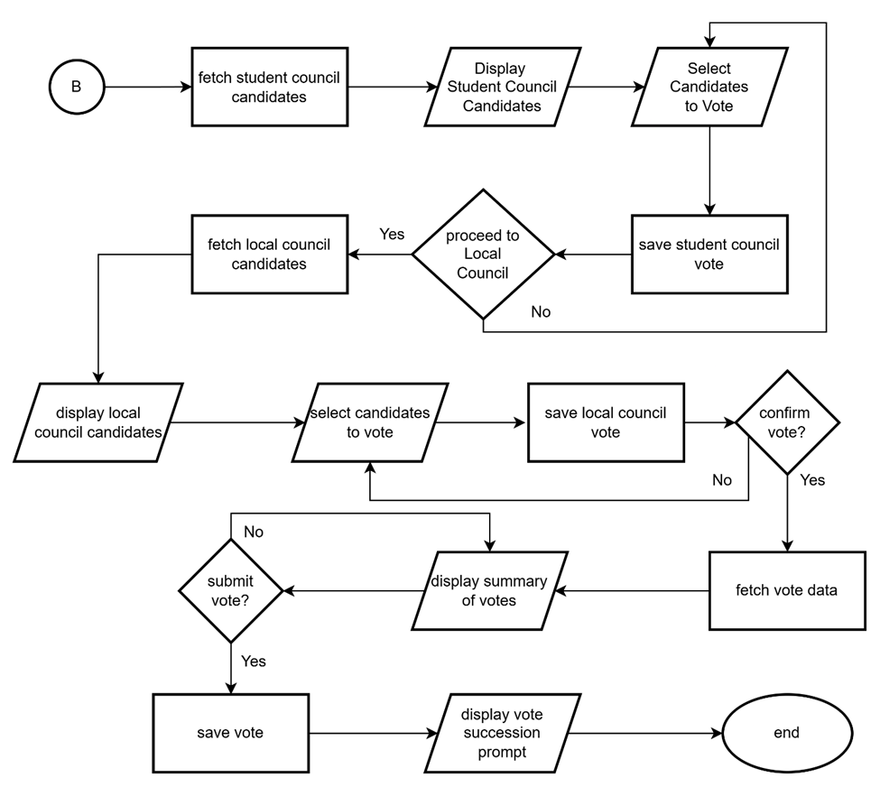

Figure 3.15 System Flowchart of E-Votar Voter User

Figure 3.15 shows how a voter user interacts with the e-votar system. The process begins with fetching student council candidates and displaying them to the voter. The voter then selects candidates to vote for in the student council, and the system saves the student council vote. Next, the voter is prompted to proceed to the local council vote. If the voter agrees, the system fetches and displays local council candidates. The voter selects candidates to vote for in the local council, and the system saves the local council vote. The voter is then asked to confirm the vote. If confirmed, the system fetches the vote data, displays a summary of votes, and prompts for final vote submission. Upon submission, the system saves the vote and displays a vote succession prompt before ending the process.

## Context Data Flow Diagram

The context flow diagram illustrates the boundaries and interactions between the e-votar system and its five users: the superadmin, administrator, voter/user, watcher and the technical officer. It provides a high-level view of the data flows between the system and various stakeholders, ensuring a comprehensive understanding of how information is exchanged and processed. This diagram is crucial for identifying key requirements and guiding the development process.

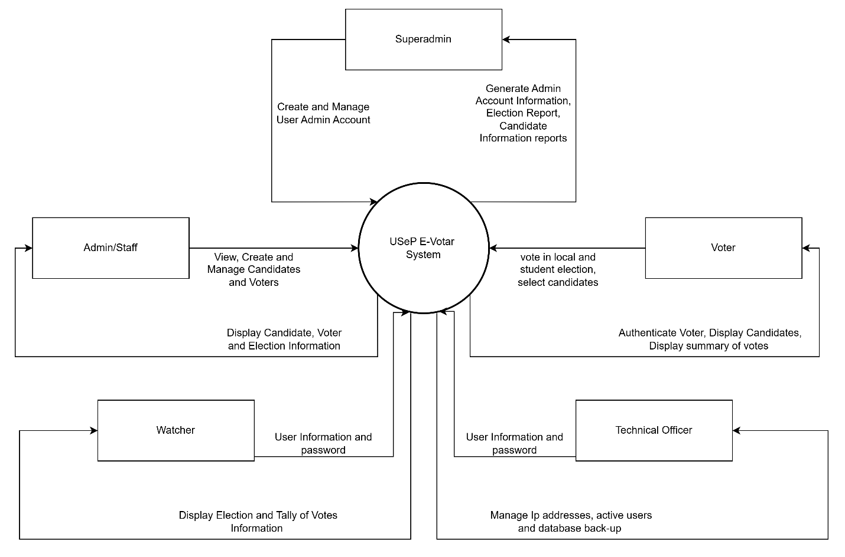

Figure 3.16 Context Data Flow (Level 0) Diagram E-votar Application

Figure 3.16 presents the context data flow diagram of the E-votar application which shows the five users: the superadmin, administrator, voter/user, watcher and the technical officer on their respective functions towards the system likewise from the system unto them in a generalized form.

The super admin's function is critical in managing the complete data management process. The system generates data reports primarily to help super admins with their jobs. Regarding election officials, the super admin has the right to oversee the whole election process, including full access to voter and candidate information and the ability to initiate or terminate the election. While the admin has the authority to maintain (edit, add, delete) the system's data. Meanwhile, the technical officer is responsible for managing user data and guaranteeing its security, which includes tasks like performing database backups and monitoring user activities. Additionally, the election watcher oversees observing election outcomes in real time. Users are needed to enter login information and cast votes during the election. Additionally, the election watcher oversees observing election outcomes in real time. Users are needed to enter login information and cast votes during the election.

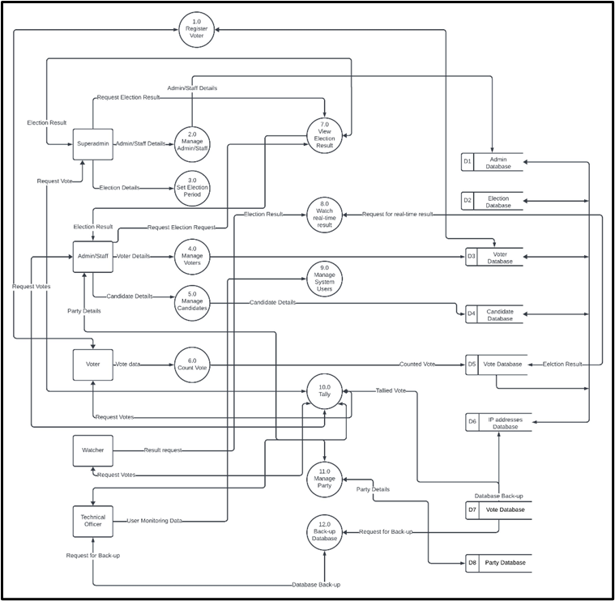

Figure 3.17 Data Flow Diagram (Level 1) of E-votar System

Figure 3.17 presents the level 1 of the context data flow diagram of the e-votar system. It depicts the interactions between various user roles (Superadmin, Admin/Staff, Voter, Watcher, and Technical Officer) and the system's key processes such as managing admin/staff, setting election periods, managing voters and candidates, casting votes, viewing election results, watching real-time results, managing system users, and backing up the database. These processes interact with several databases, including the Admin, Election, Voter, Candidate, Vote, and IP Addresses databases, ensuring comprehensive management and secure handling of election-related data.

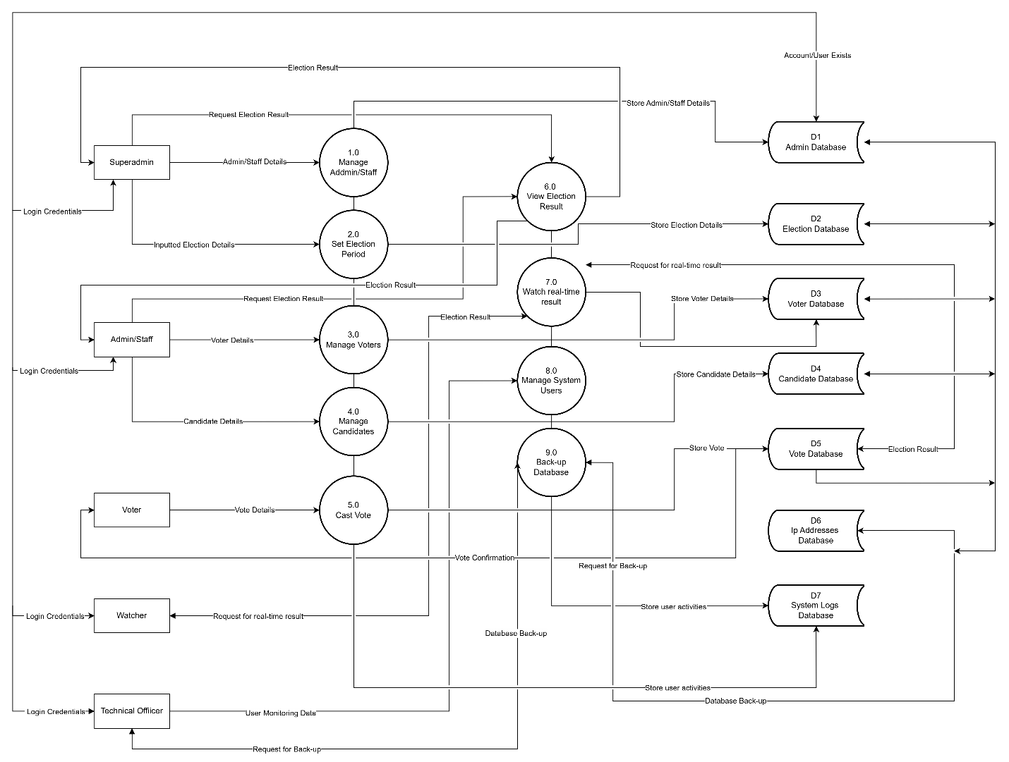

Figure 3.18 Physical Data Flow Diagram of E-votar System

Figure 3.18 shows the physical data flow diagram for the e-votar system. It details the interactions between user roles (Superadmin, Admin/Staff, Voter, Watcher, and Technical Officer) and system processes such as managing admin/staff, setting election periods, managing voters and candidates, casting votes, viewing election results, watching real-time results, managing system users, and backing up the database. Each process interacts with specific databases including Admin, Election, Voter, Candidate, Vote, IP Addresses, and System Logs databases, ensuring the secure and efficient handling of login credentials, election details, voter details, candidate details, votes, and system activities.

## Entity Relationship Diagram

The entity relationship diagram (ERD) is a crucial component in the design phase. It provides a detailed visual representation of the relationships between different entities and their attributes and serves as a valuable tool for understanding how data is organized and related within the database. This diagram helps us identify and define the various data elements that will be incorporated, laying the foundation for a well-structured and efficient database.

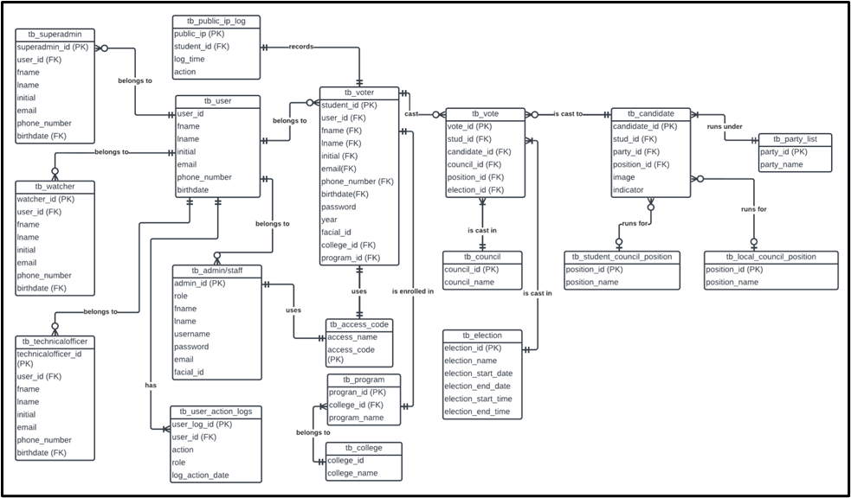

**Figure 3.19** Entity Relationship Diagram (ERD) of E-Votar

Figure 3.19 shows the entity-relationship diagram of e-votar system. This diagram illustrates the relationships between various tables used to manage the voting process.

## Prototype

In this phase, the developers created a prototype of the web-based e-votar system.

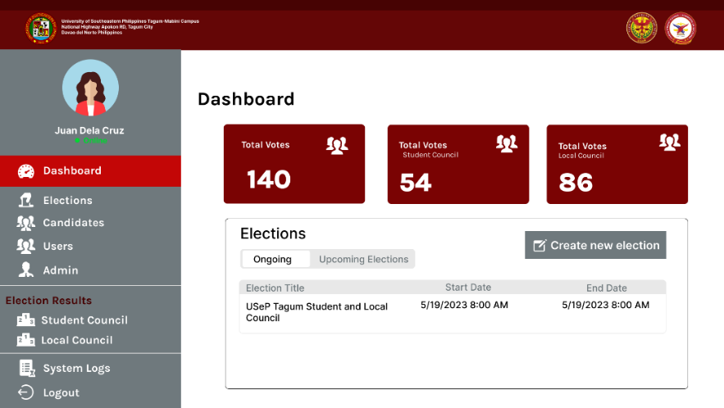

Figure 3.20 (A)

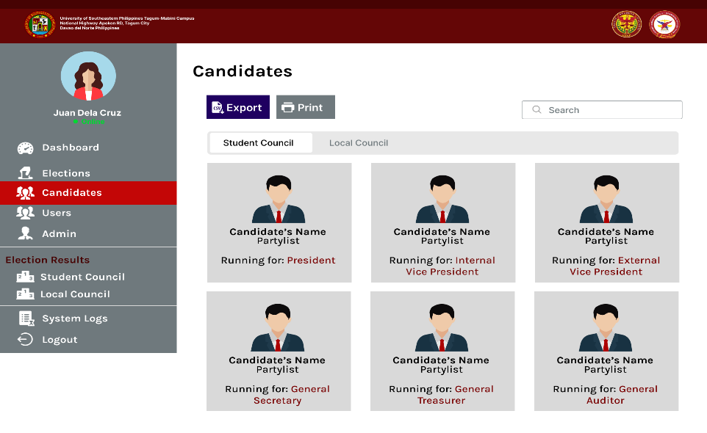

(B)

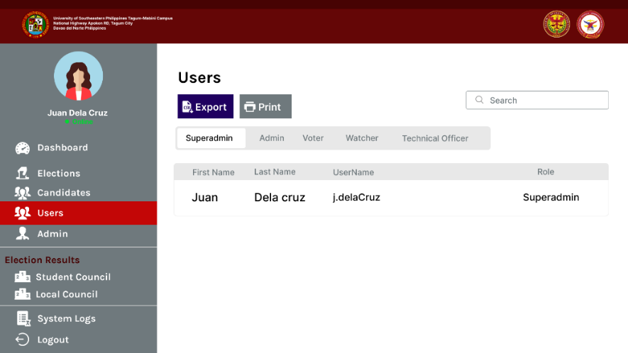

(C)

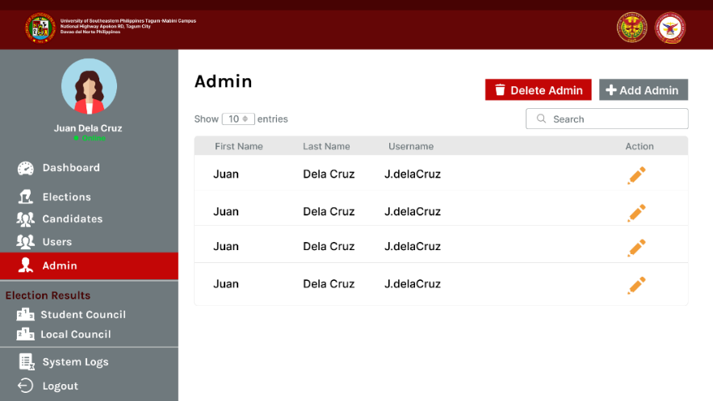

(D)

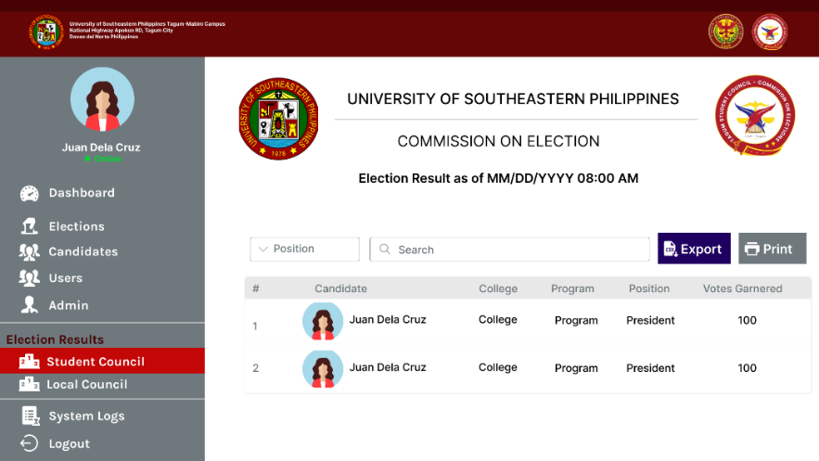

(E)

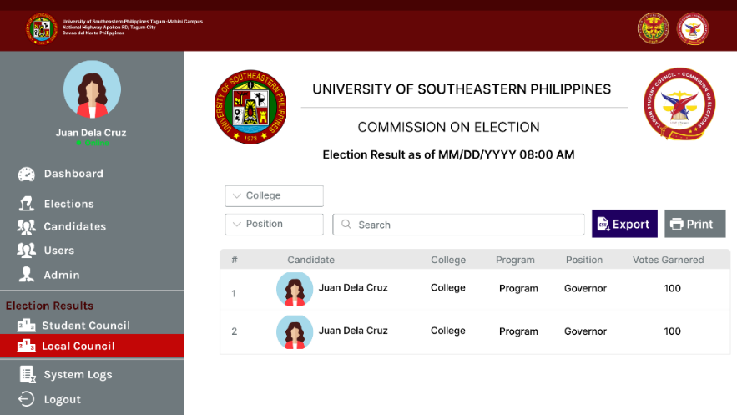

(F)

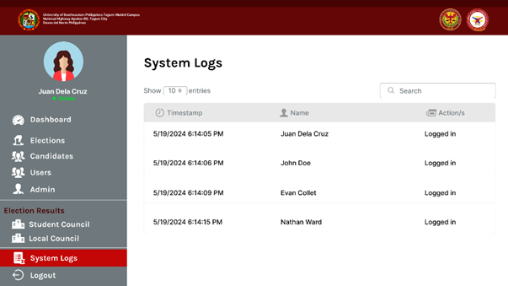

(G)

Figure 3.20 (A) (B) (C) (D) (E) (F) and (G) Mock-up of the e-votar system for superadmin user

Figure 3.20 shows the mock-up of the web-based of e-votar system. Figure 3. 20.A shows the dashboard of e-votar system for the superadmin user, show the total number of votes, the total number of student council votes, and the total number of local council votes. The dashboard also shows a list of ongoing elections and a list of upcoming elections. The superadmin can create a new election by clicking on the "Create new election" button. Figure 3. 20.B displays all candidates for both the student council and the local council. The superadmin has the capability to export or print this list.

Figure 3.20.C displays the list of users along with their respective roles, including superadmin, admin, voter, watcher, and technical officer. The superadmin has the capability to export or print this list. Figure 3.20.D shows the admin account management page, where superadmin can add, edit, or delete admin accounts. Figure 3.20.E displays the election results page for the student council, including the list of candidates along their respective colleges and programs, the position they ran for, and the number of votes they garnered. Additionally, this page features buttons that allow the superadmin to export or print the results. Figure 3.20.F displays the election results page for the local council, including the list of candidates along their respective colleges and programs, the position they ran for, and the number of votes they garnered. Additionally, this page features buttons that allow the superadmin to export or print the results. Figure 3.20.G displays the System Logs page, which records and presents a detailed list of system activities and user actions. This page includes entries with timestamps, descriptions of the actions performed, and the names of those who executed the actions.

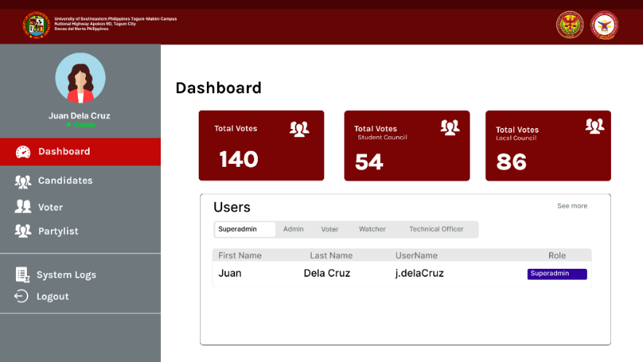

Figure 3.21 (A)

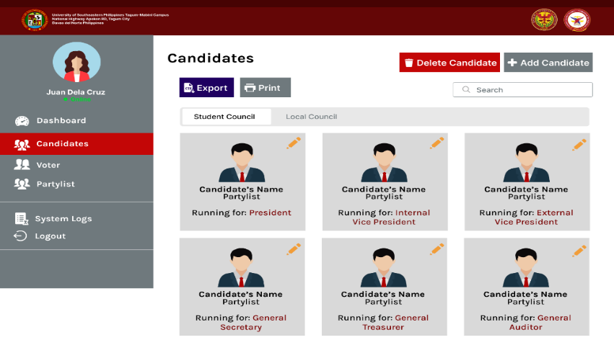

(B)

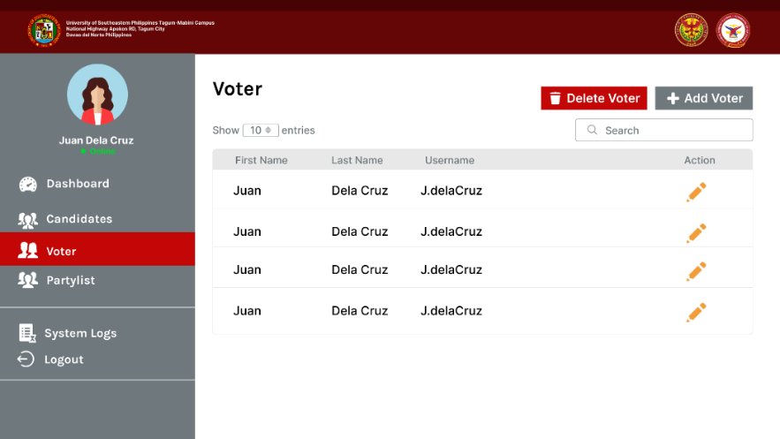

(C)

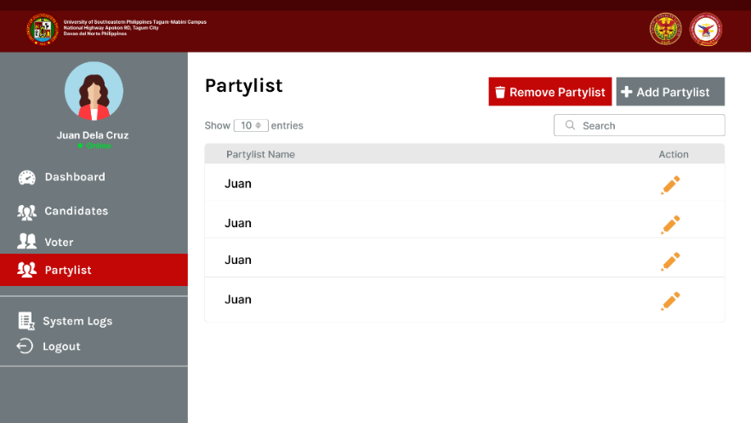

(D)

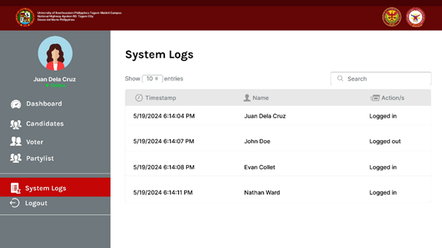

(E)

Figure 3.21 (A) (B) (C) (D) and (E) Mock-up of the e-votar system for admin user

Figure 3.21 shows the mock-up of the web-based of e-votar system. Figure 3.21.A shows the dashboard of e-votar system for the admin user, showing the total number of votes, the total number of student council votes, and the total number of local council votes. The dashboard also shows an option where the admin can choose what type of user is to be displayed. Figure 3.21.B shows the candidates account management page for both the student council and the local council, where admin can add, edit, or delete candidate accounts. Additionally, this page features buttons that allow the admin to export or print the list of candidates. Figure 3.21.C. shows the voter account management page, where the admin can add, edit, or delete voter accounts. Figure 3.21.D. shows the partylist management page, where the admin can add, edit, or remove a specific partylist. Figure 3.21.E displays the System Logs page, which records and presents a detailed list of system activities and user actions. This page includes entries with timestamps, descriptions of the actions performed, and the names of those who executed the actions.

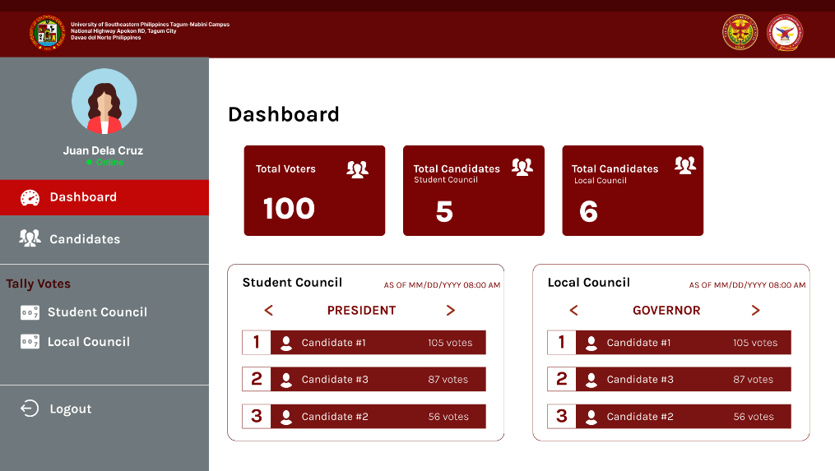

Figure 3.22 (A)

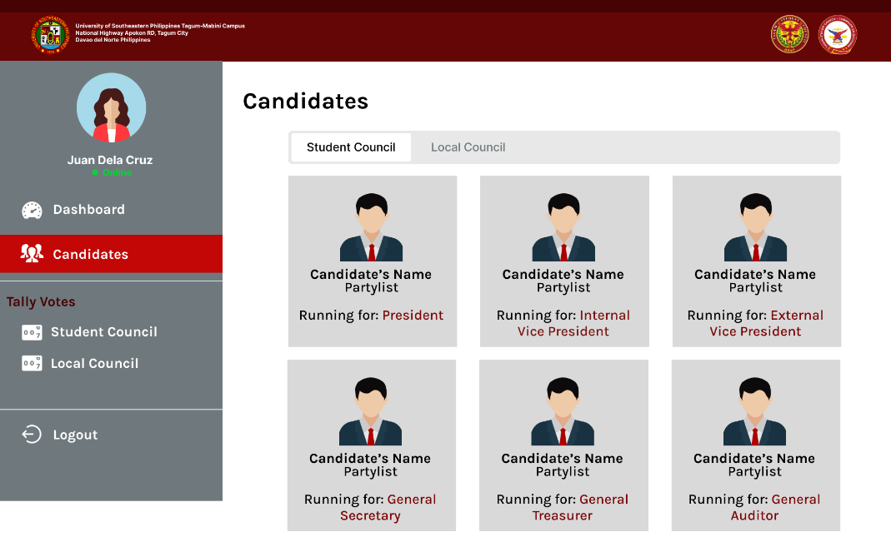

(B)

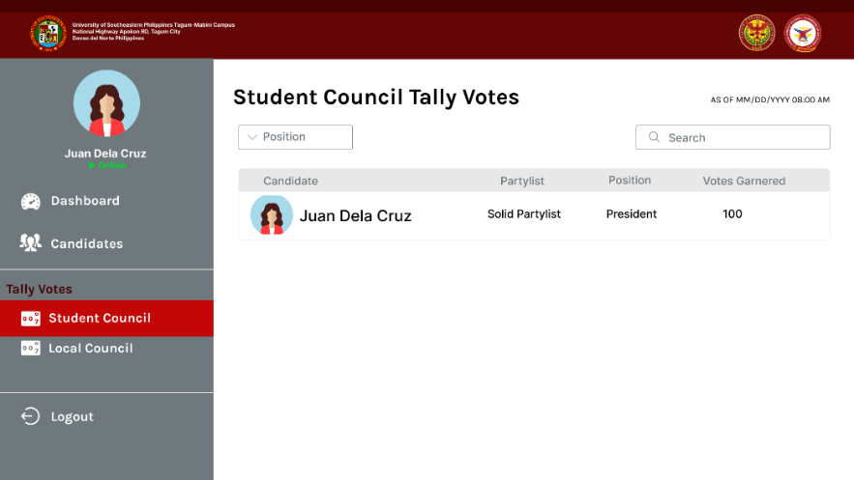

(C)

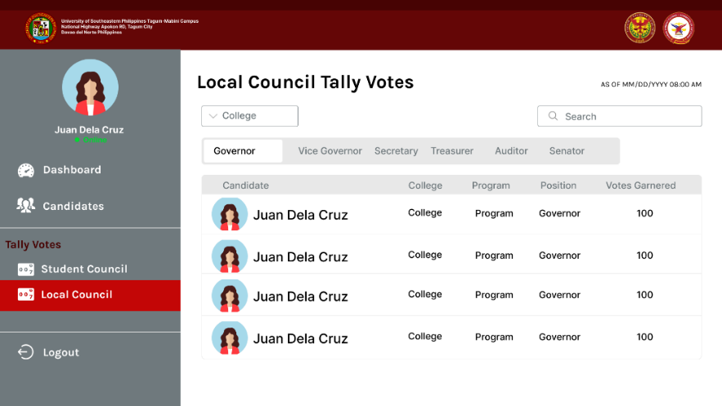

(D)

Figure 3.22 (A) (B) (C) and (D) Mock-up of the e-votar system for watcher users

Figure 3.22 shows the mock-up of the web-based of e-votar system. Figure 3.22.A shows the dashboard of e-votar system for the watcher user, showing the total number of votes, the total number of student council votes and the total number of candidates for the Local Council. Below these statistical summaries, detailed vote counts for each position in the Student Council and Local Council are provided. Figure 3.22.B displays all candidates for both the student council and the local council. Figure 3.22.C displays the tally votes page for student council where the watcher can view the candidate’s name, their partylist, position, and the number of votes garnered. This page has also an option for the watcher to filter by position and search for specific candidates. Figure 3.22.D displays the tally votes page for local council where the watcher can view the candidate’s name, their partylist, position, and the number of votes garnered. This page has also an option for the watcher to filter by college, position and search for specific candidates.

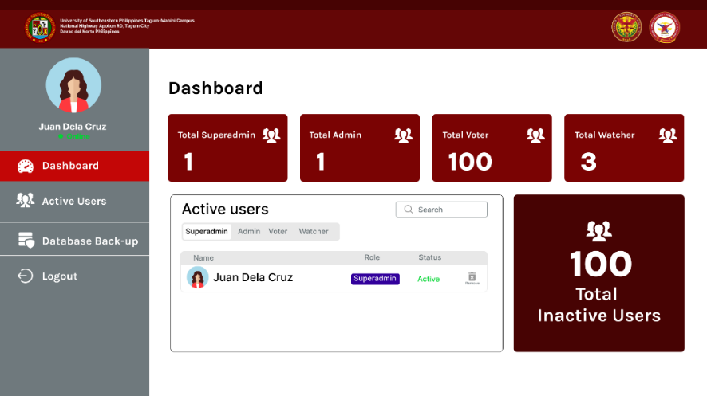

Figure 3.23 (A)

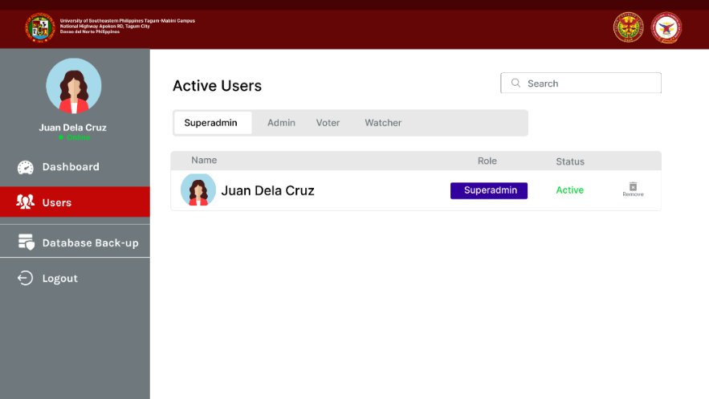

(B)

Figure 3.23 (A) and (B) Mock-up of the e-votar system for technical officer users

Figure 3.23 shows the mock-up of the web-based of e-votar system. Figure 3.23.A shows the dashboard of e-votar system for the technical officer user, showing the total number of superadmin, admin, voter, and watcher. Below these statistical summaries are the active users of superadmin, admin, voter and watcher. The page also shows the total number of inactive users. Figure 3.23.B shows the detailed list of active users of superadmin, admin, voter and watcher.

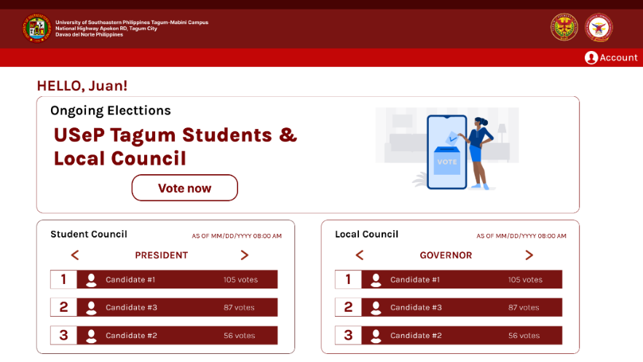

Figure 3.24 (A)

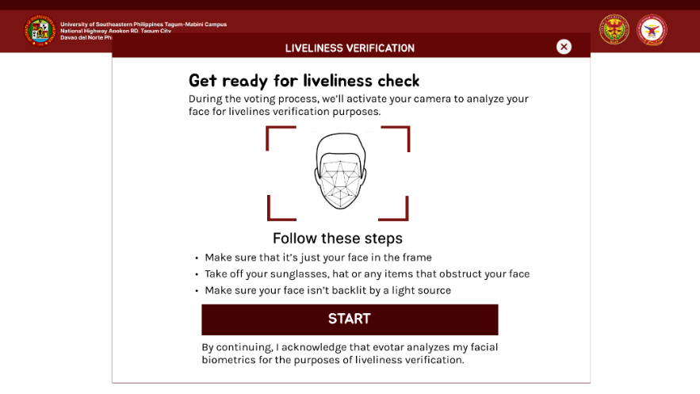

(B)

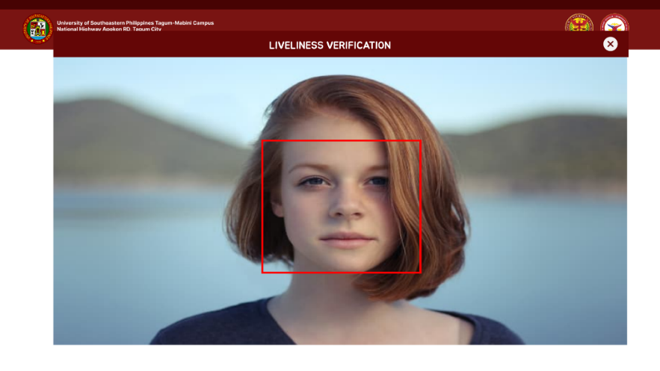

(C)

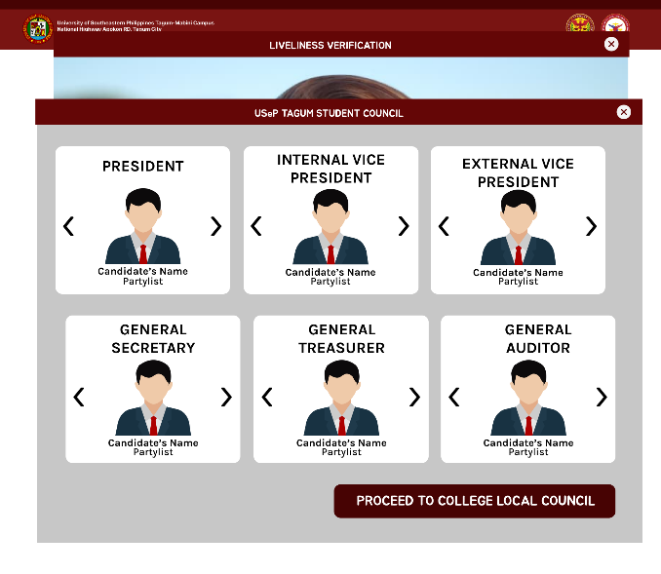

(D)

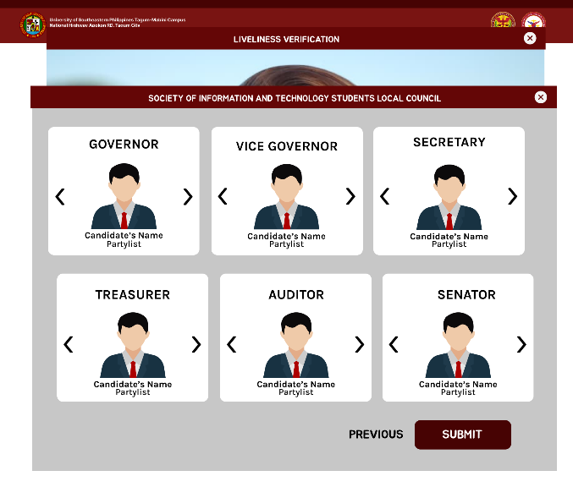

(E)

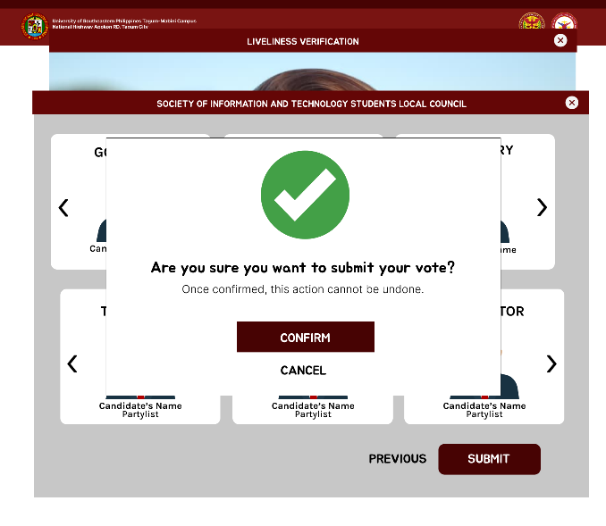

(F)



(G)

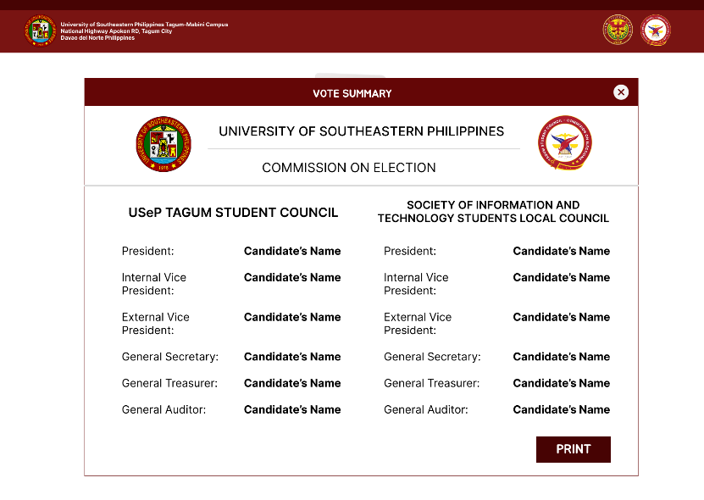

(H)

Figure 3.24 (A)(B)(C)(D)(E)(F)(G) and (H) Mock-up of the e-votar system for voter users

Figure 3.24 shows the mock-up of the web-based of e-votar system. Figure 3. 24.A

shows the ongoing elections page where voters can vote to student and local council election. Below it is the detailed vote counts for each position in the Student Council and Local Council. Figure 3.24.B shows the liveliness verification page, where users are instructed to prepare for a liveliness check before to proceed in voting. The page informs users that their camera will be activated to analyze their face for liveliness verification purposes. Figure 3.24.C shows the liveliness verification page in progress where the voter’s face is being analyzed for liveliness verification. Figure 3. 24.D shows the student council election page. The page features sections for various positions within the student council, including President, Internal Vice President, External Vice President, General Secretary, General Treasurer, and General Auditor. At the bottom, there is a button labeled "PROCEED TO COLLEGE LOCAL COUNCIL" to navigate to the next step in the election process. Figure 3.24.E shows the local council election page for the Society of Information and Technology Students. The page features sections for various positions within the local council, including Governor, Vice Governor, Secretary, Treasurer, Auditor, and Senator. At the bottom, there are buttons labeled "PREVIOUS" and "SUBMIT" to navigate between pages and submit the election choices, respectively. Figure 3.24.F shows a vote submission confirmation dialog for the local council election page of the Society of Information and Technology Students. In this dialog box, there are two buttons: "CONFIRM" to finalize the vote submission and "CANCEL" to return to the previous screen. Figure 3.24.G shows a confirmation page for a voting system. The page includes two buttons: one labeled "BACK TO HOMESCREEN" and the other labeled "SEE VOTE SUMMARY." Figure 3.24.H shows the vote summary page, detailing the votes cast by the voters. This page features buttons that is located at the bottom right corner of the summary which allow the voter to print the vote summary.



Figure 3.25 (A)

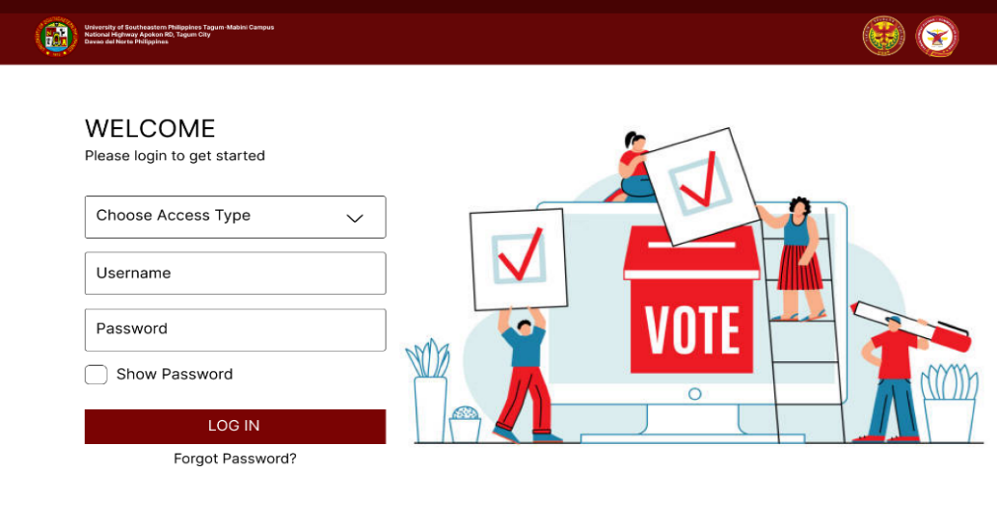

(B)

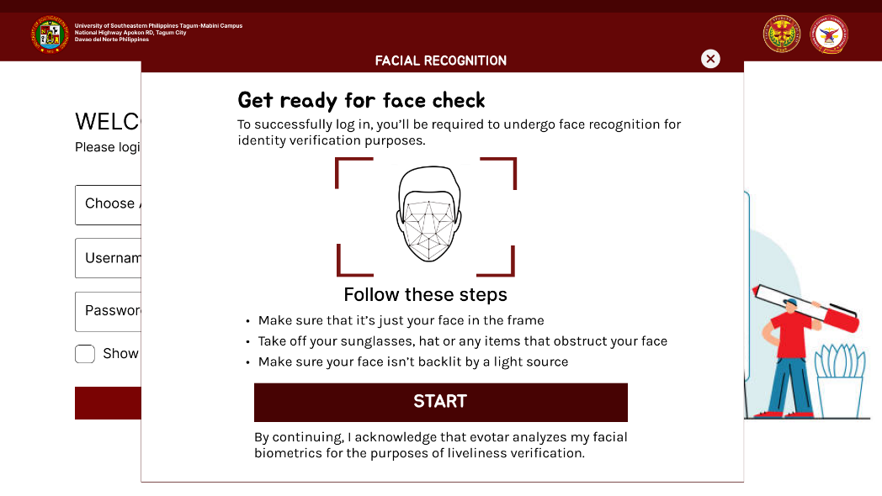

(C)

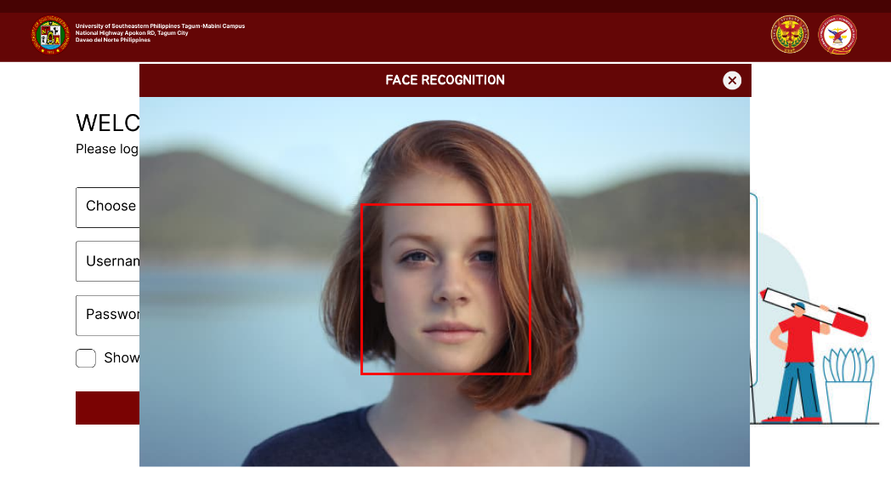

(D)

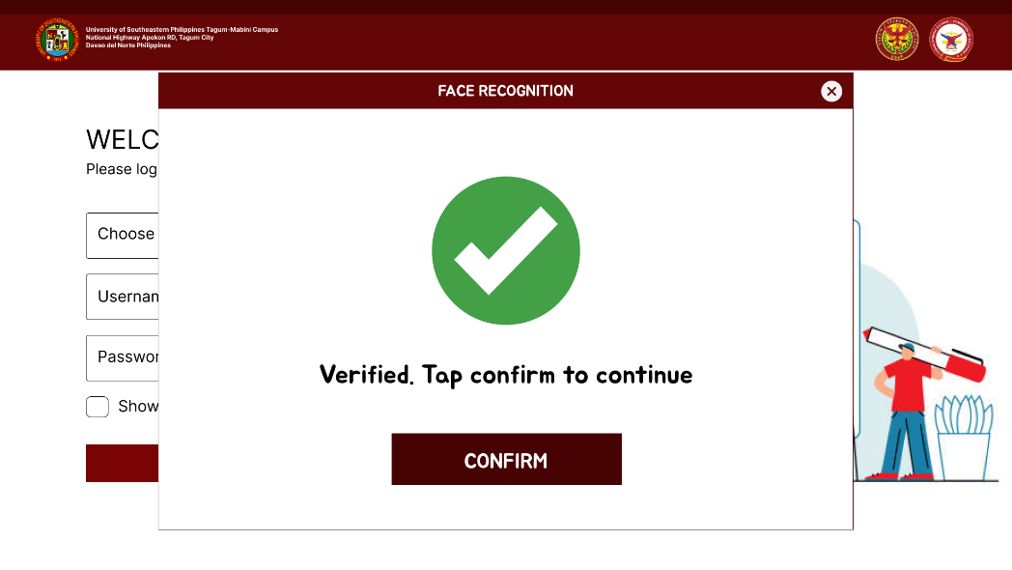

(E)

Figure 3.25 (A)(B)(C)(D) and (E) Mock-up of the login process in the e-votar system

Figure 3.25 shows the mock-up of the web-based of e-votar system. Figure 3.25.A shows the privacy notice page of a login screen for the e-votar system. The page includes an "AGREE AND CONTINUE" button at the bottom. Figure 3.25.B shows the login screen for the e-votar system. The page includes fields for choosing the access type, entering a username and password, and an option to show the password. There is a "LOG IN" button and a "Forgot Password?" link at the bottom. Figure 3.25.C shows the facial recognition verification page, where users are instructed to prepare for a facial recognition before to successfully logged in. The page informs users that their camera will be activated to analyze their face for liveliness verification purposes. Figure 3.25.D shows the facial recognition page in progress where the voter’s face is being analyzed for identity verification. Figure 3.25.E shows the face recognition verification page of a login screen for the e-votar system. The page includes a "CONFIRM" button at the bottom, indicating that the user has been verified and can proceed by tapping the button.

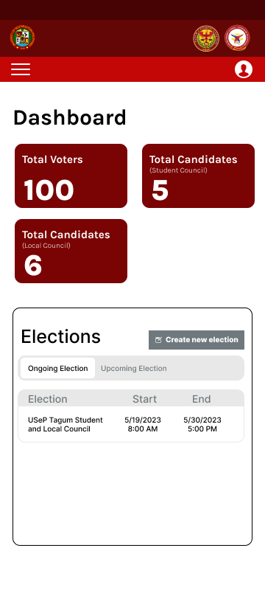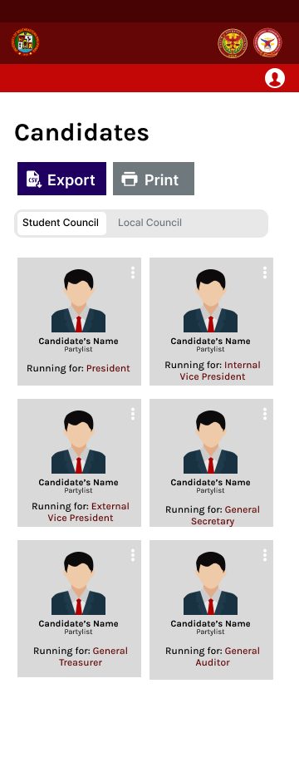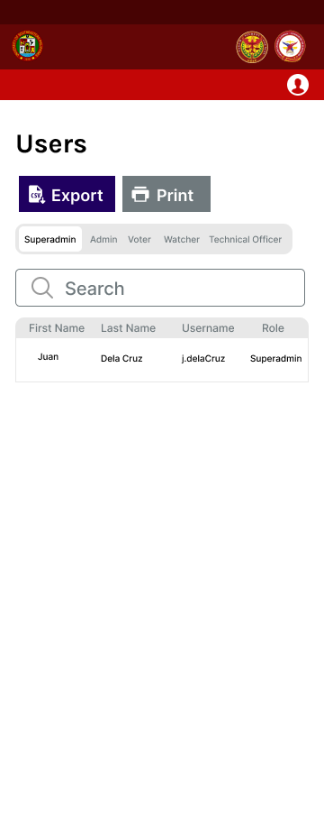

 Figure 3.26 (A) (B) 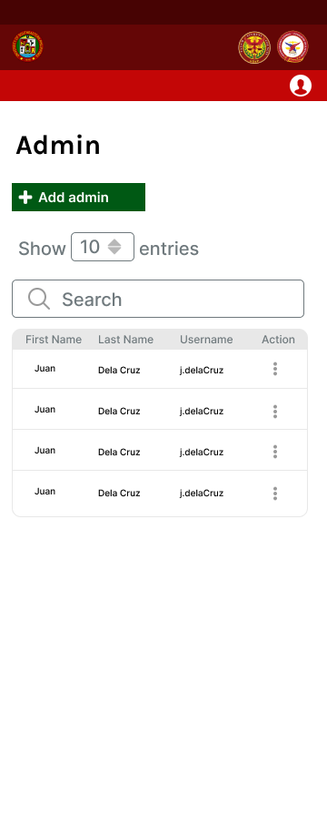 (C)



(D) (E) (F)

Figure 3.26 (A)(B)(C)(D)(E) and (F) Mock-up of the e-votar system in mobile interface for superadmin user

Figure 3.26 shows the mock-up of the e-votar system in mobile interface for superadmin user. Figure 3.26.A shows the dashboard of e-votar system for the superadmin user, show the total number of votes, the total number of student council votes, and the total number of local council votes. The dashboard also shows a list of ongoing elections and a list of upcoming elections. The superadmin can create a new election by clicking on the "Create new election" button. Figure 3.26.B displays all candidates for both the student council and the local council. The superadmin has the capability to export or print this list. Figure 3.26.C displays the list of users along with their respective roles, including superadmin, admin, voter, watcher, and technical officer. The superadmin has the capability to export or print this list.

Figure 3.26.D shows the admin account management page, where superadmin can add, edit, or delete admin accounts. Figure 3.26.E displays the election results page for the student council, including the list of candidates along their respective colleges and programs, the position they ran for, and the number of votes they garnered. Additionally, this page features buttons that allow the superadmin to export or print the results. Figure 3.26.F displays the election results page for the local council, including the list of candidates along their respective colleges and programs, the position they ran for, and the number of votes they garnered. Additionally, this page features buttons that allow the superadmin to export or print the results. Figure 3.26.G displays the System Logs page, which records and presents a detailed list of system activities and user actions. This page includes entries with timestamps, descriptions of the actions performed, and the names of those who executed the actions.

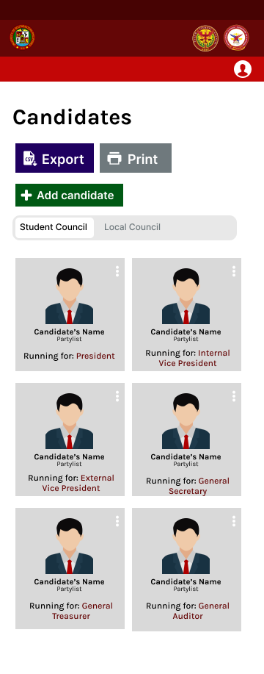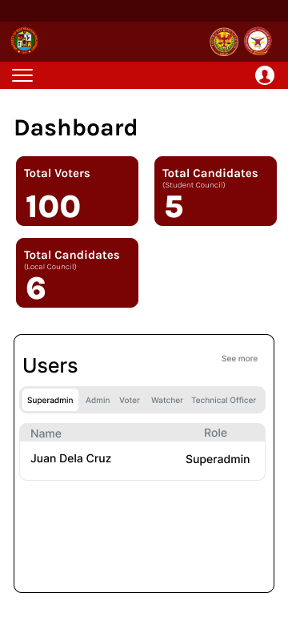

Figure 3.27 (A) (B) (C)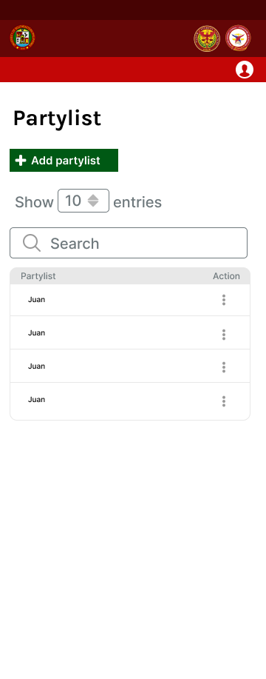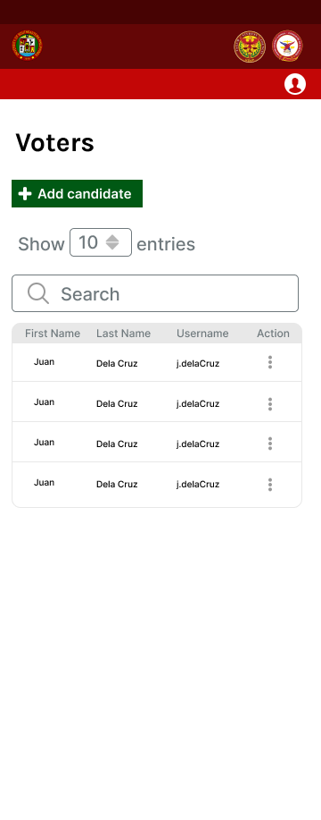

(D) (E)

Figure 3.27 (A)(B)(C)(D) and (E) Mock-up of the e-votar system in mobile interface for admin user

Figure 3.27 shows the mock-up of the e-votar system in mobile interface for admin user. Figure 3.27.A shows the dashboard of e-votar system for the admin user, showing the total number of votes, the total number of student council votes, and the total number of local council votes. The dashboard also shows an option where the admin can choose what type of user is to be displayed.

Figure 3.27.B shows the candidates account management page for both the student council and the local council, where admin can add, edit, or delete candidate accounts. Additionally, this page features buttons that allow the admin to export or print the list of candidates. Figure 3.27.C. Shows the voter account management page, where the admin can add, edit, or delete voter accounts. Figure 3.27.D. Shows the partylist management page, where the admin can add, edit, or remove a specific partylist. Figure 3.27.E displays the System Logs page, which records and presents a detailed list of system activities and user actions. This page includes entries with timestamps, descriptions of the actions performed, and the names of those who executed the actions.

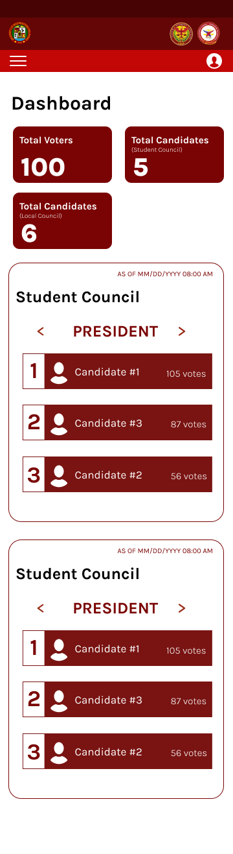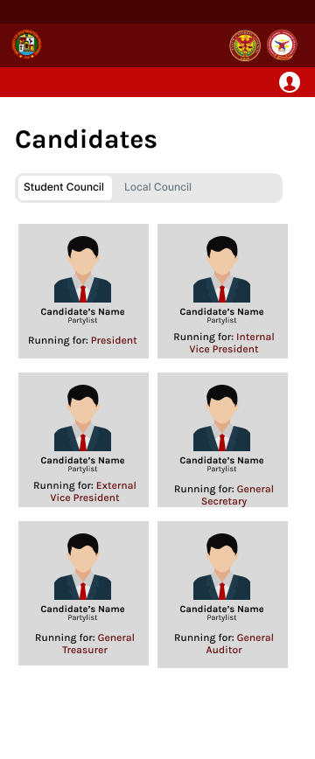

(B) (C)



(A)

(D)

Figure 3.28 (A)(B)(C) and (D) Mock-up of the e-votar system in mobile interface for watcher user

Figure 3.28 shows the mock-up of the web-based of e-votar system. Figure 3.28.A shows the dashboard of e-votar system for the watcher user, showing the total number of votes, the total number of student council votes and the total number of candidates for the Local Council. Below these statistical summaries, detailed vote counts for each position in the Student Council and Local Council are provided. Figure 3.28.B displays all candidates for both the student council and the local council. Figure 3.28.C displays the tally votes page for student council where the watcher can view the candidate’s name, their partylist, position, and the number of votes garnered. This page has also an option for the watcher to filter by position and search for specific candidates. Figure 3.28.D displays the tally votes page for local council where the watcher can view the candidate’s name, their partylist, position, and the number of votes garnered. This page has also an option for the watcher to filter by college, position and search for specific candidates.

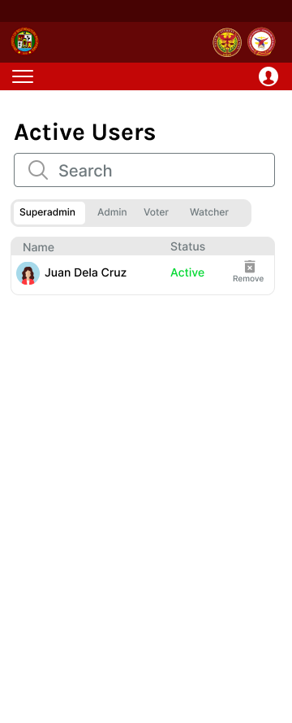

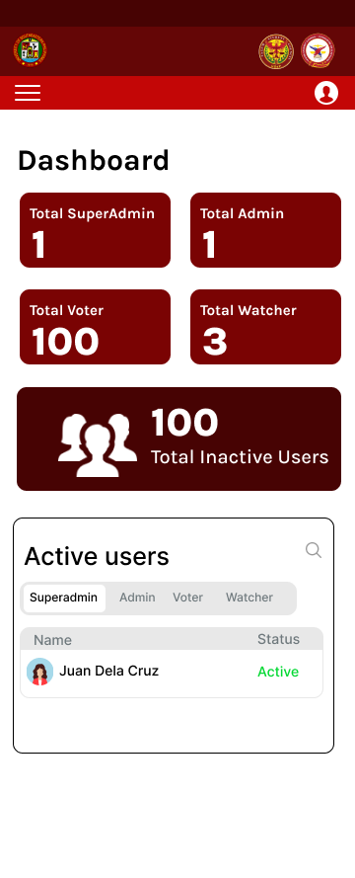

(A) (B)

Figure 3.29 (A) and (B) Mock-up of the e-votar system in mobile interface for technical officer user

Figure 3.29 shows the mock-up of the e-votar system in mobile interface for technical officer user. Figure 3.29.A shows the dashboard of e-votar system for the technical officer user, showing the total number of superadmin, admin, voter, and watcher. Below these statistical summaries are the active users of superadmin, admin, voter and watcher. The page also shows the total number of inactive users. Figure 3.29.B shows the detailed list of active users of superadmin, admin, voter and watcher.

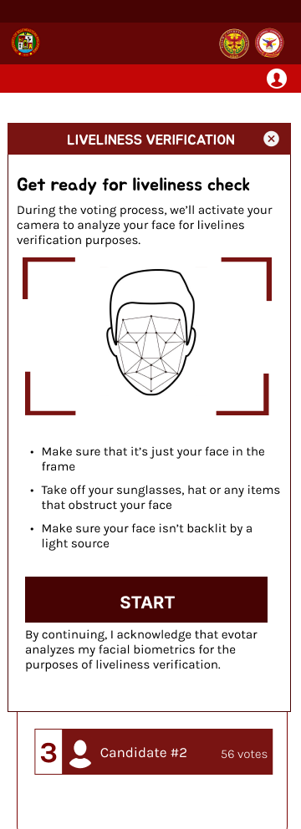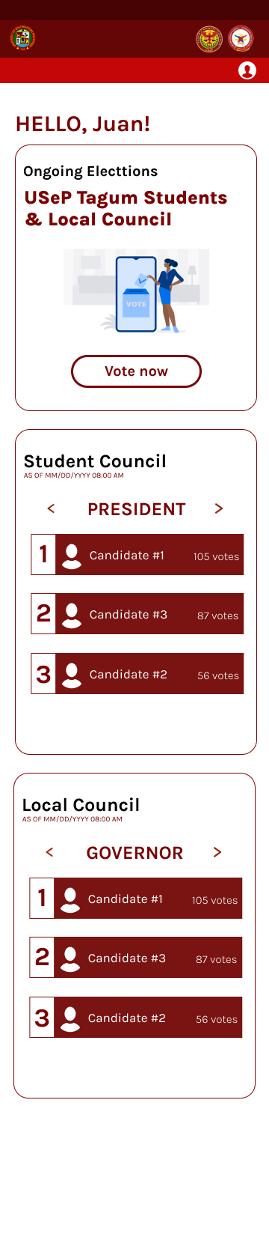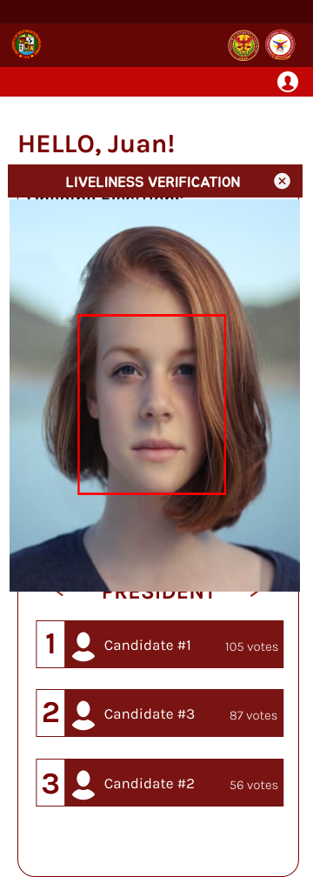

(B) (C)

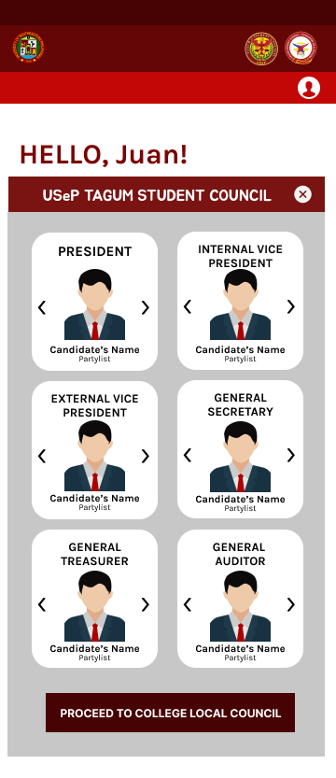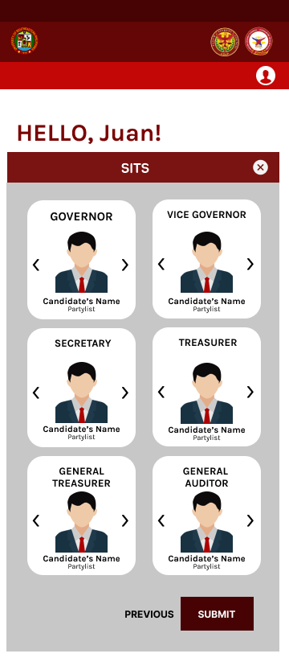

(D) (E)

(A)

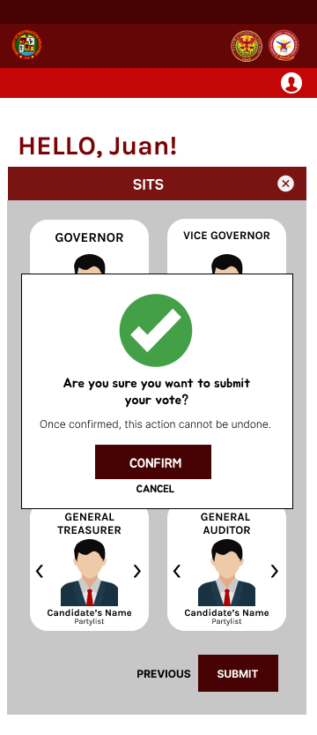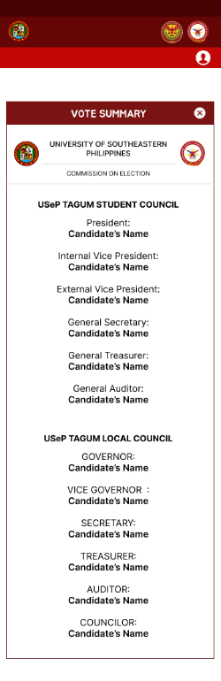

(F) (G)

(H)

Figure 3.30 (A)(B)(C)(D)(E)(F)(G) and (H) Mock-up of the e-votar system in mobile interface for voter user

Figure 3.30 shows the mock-up of the e-votar system in mobile interface for voter user. Figure 3.30.A shows the ongoing elections page where voters can vote to student and local council election. Below it is the detailed vote counts for each position in the Student Council and Local Council. Figure 3.30.B shows the liveliness verification page, where users are instructed to prepare for a liveliness check before to proceed in voting. The page informs users that their camera will be activated to analyze their face for liveliness verification purposes. Figure 3.30.C shows the liveliness verification page in progress where the voter’s face is being analyzed for liveliness verification. Figure 3.30.D shows the student council election page. The page features sections for various positions within the student council, including President, Internal Vice President, External Vice President, General Secretary, General Treasurer, and General Auditor. At the bottom, there is a button labeled "PROCEED TO COLLEGE LOCAL COUNCIL" to navigate to the next step in the election process.

Figure 3.30.E shows the local council election page for the Society of Information and Technology Students. The page features sections for various positions within the local council, including Governor, Vice Governor, Secretary, Treasurer, Auditor, and Senator. At the bottom, there are buttons labeled "PREVIOUS" and "SUBMIT" to navigate between pages and submit the election choices, respectively. Figure 3.30.F shows a vote submission confirmation dialog for the local council election page of the Society of Information and Technology Students. In this dialog box, there are two buttons: "CONFIRM" to finalize the vote submission and "CANCEL" to return to the previous screen. Figure 3.30.G shows a confirmation page for a voting system. The page includes two buttons: one labeled "BACK TO HOMESCREEN" and the other labeled "SEE VOTE SUMMARY." Figure 3.30.H shows the vote summary page, detailing the votes cast by the voters. This page features buttons that is located at the bottom right corner of the summary which allow the voter to print the vote summary.

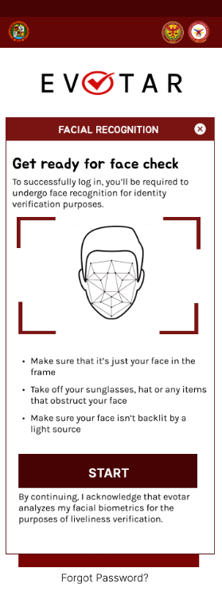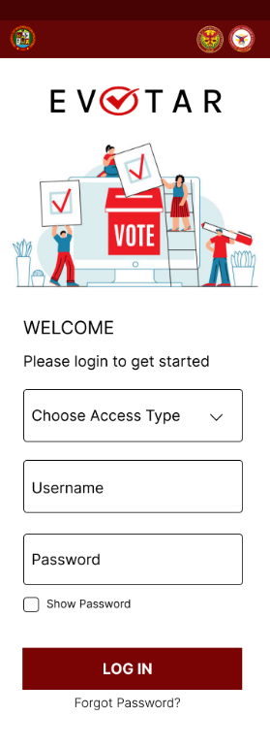

(A) (B) (C)

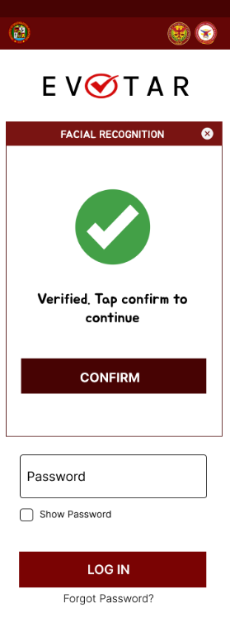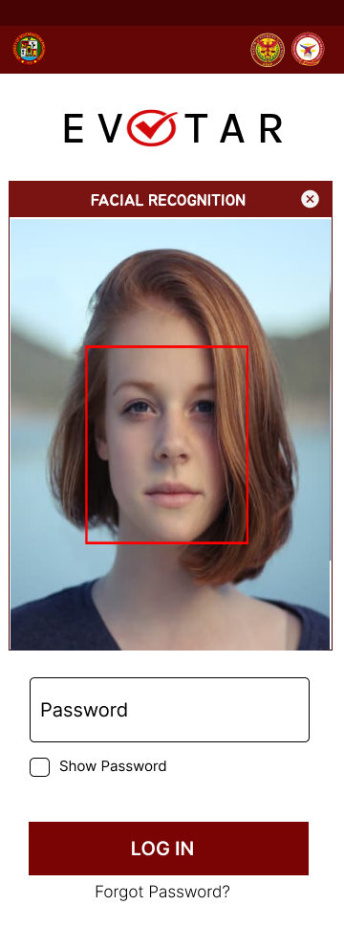

(D) (E)

Figure 3.31 (A)(B)(C)(D) and (E) Mock-up of the login process of the e-votar system in mobile interface

Figure 3.31 shows the mock-up of the login process of the e-votar system in mobile interface. Figure 3.31.a shows the privacy notice page of a login screen for the e-votar system. The page includes an "agree and continue" button at the bottom. Figure 3.31.b shows the login screen for the e-votar system. The page includes fields for choosing the access type, entering a username and password, and an option to show the password. There is a "log in" button and a "forgot password?" link at the bottom. Figure 3.31.c shows the facial recognition verification page, where users are instructed to prepare for a facial recognition before to successfully logged in. The page informs users that their camera will be activated to analyze their face for liveliness verification purposes. Figure 3.31.d shows the facial recognition page in progress where the voter’s face is being analyzed for identity verification. Figure 3.31.e shows the face recognition verification page of a login screen for the e-votar system. The page includes a "confirm" button at the bottom, indicating that the user has been verified and can proceed by tapping the button.

**Phase 3: Development**

During this stage, developers concentrate on coding and design, carefully examining and reviewing each step to ensure efficiency. This phase is critical in the development process because of the duration, the commencement of the actual development process, and the difficulties encountered. It is where the previous phases' goals, concepts, and efforts come to occur, resulting in the actual structure of the application being implemented. Furthermore, the application will use PHPStorm as its integrated development environment (IDE) for system development.

The developers will also utilize WAMPP and MySQL, WAMP, a windows-based web development platform that allows to create dynamic web applications using Apache2, PHP, MySQL, and MariaDB. The next application that the developers will utilize is MySQL which is one of the most used open-source Relational Database Management Systems (RDMS) using a basic Client-Server Model. The developers will also use WAMPP and MySQL. WAMPP is a Windows-based web development platform that lets you create dynamic web applications using Apache2, PHP, MySQL, and MariaDB. Additionally, MySQL, a popular open-source Relational Database Management System (RDMS), will be used. It follows a basic Client-Server model. Additionally, the Figma designs created by the designers will serve as a template for developing the interface of the application. Lastly, the developers will merge the code and design being developed and assess the outcomes.

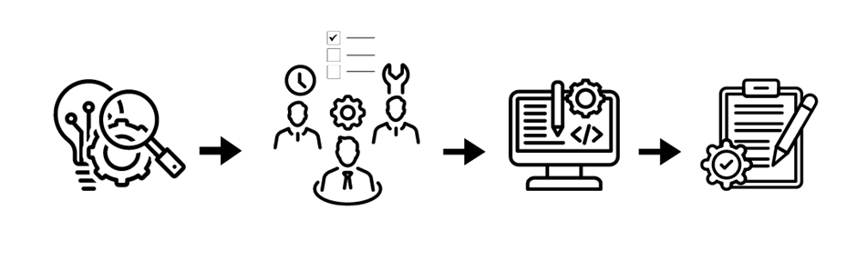

Figure 3.32 Development Phase

Presented in the Figure 3.32 This phase shows how developers manage multiple tasks, distribute time and effort efficiently, assign roles based on each member's capabilities and skills, coding and design components, and finally document all reports, data, and achievements throughout the development process.

**Phase 4: Testing**

During the testing phase, the development team will meticulously verify that all features and functionalities have been implemented in accordance to the project specifications. The e-votar system will undergo extensive testing to evaluate its capacity to reliably capture and tabulate votes, ensure data security, and provide an intuitive user interface. This phase guarantees that the e-votar system will be fully prepared for deployment.

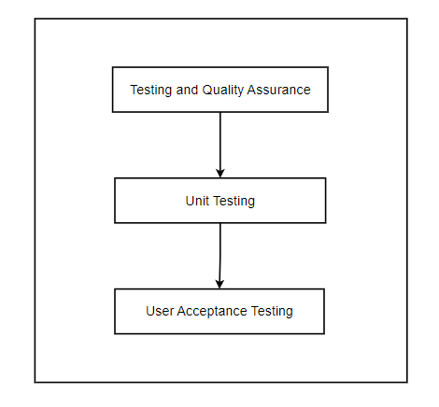

Figure 3.33 Testing Phase

Figure 3.21 shows the software development process, emphasizing testing and quality assurance trough unit testing and user acceptance testing. Unit testing involves the detailed examination of individual components of the e-votar system to ensure that each part functions correctly. This step is followed by user acceptance testing, where the system is evaluated by end-users to confirm that it meets their requirements and performs as expected.

**Phase 5: Deployment**

This phase puts the product into the production process. Right after extensive testing phases conducted by the developer team in collaboration with the advisor, which included intense examination, in-depth analysis, and the implementation of various changes throughout the development process, the testing was completed successfully, and the application is now ready for deployment. Figure 3.22 illustrates the application's deployment process from this point out, beginning with the display of the program to users and progressing through deployment preparation, including agreements and conditions. Following completion of these procedures, the application is formally handed over and deployed. A further review of the application is expected to ensure the performance and overall features of the application.

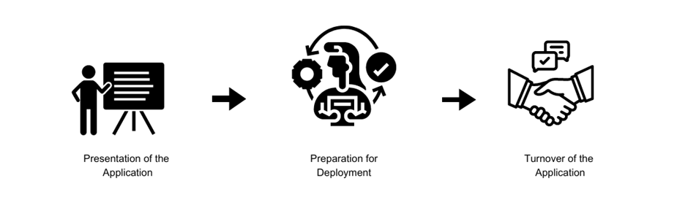

Figure 3.34 Deployment Phase

**Phase 6: Review**

Following the deployment phase, the review phase represents the culmination of the development journey for the e-votar system, serving as the ultimate assessment and validation stage. In this final phase, the development team conducts a comprehensive review of the entire system to ensure its alignment with the specified requirements and objectives. Stakeholders, including members of the University's Commission on Election and relevant administrative bodies, actively participate in assessing the system's functionality, usability, and performance.

During this phase, the development team meticulously evaluates the e-votar system to verify that all features and functionalities have been implemented according to the project specifications. Extensive testing is carried out to evaluate the system's capacity to reliably capture and tabulate votes, preserve data security, and offer an intuitive user interface. Additionally, stakeholders, including superadmin, admin, voter, watcher and technical officer play a crucial role in identifying areas for improvement or refinement by offering insightful feedback on the e-votar system. This cooperative effort guarantees that the end product satisfies the various needs and expectations of all stakeholders involved.

During the Review Phase, quality assurance measures are strictly implemented to verify the voting system's dependability, stability, and integrity. A range of testing approaches, such as functional testing, usability testing, and performance testing, are used to find and fix any problems. Comprehensive documentation is prepared to document the findings and outcomes of the review process, including stakeholder feedback and actions taken to address identified issues or recommendations.

Ultimately, the Review Phase concludes with the final approval of the e-votar system by project stakeholders, signifying their acceptance of the system as meeting the specified requirements. This completes the development process and guarantees that the voting system will be ready for use in the next elections.

# Reference

Abdul Kadir, M. F., Mohamed, M. A., Bharun, A. F. A. A., & Hamid, N. A. (2023). A Secure

Online Voting System Using Face Recognition Technology. Malaysian Journal of Computing and Applied Mathematics, 6(2), 1-9. doi:10.37231/myjcam.2023.6.1.80

Ahmad, S., Abdullah, S. A. J., & Arshad, R. B. (2015). Issues and difficulties of progress

to e-voting innovation in Nigeria. Public Policy and Administration Research, 5(4), 95–102. Retrieved from http://iiste.org/Journals/index.php/PPAR/article/see/21776

Dahnial, Dahnial. (2020). APLIKASI E-VOTING UNTUK PEMILIHAN KETUA OSIS DI

SMA XYZ BERBASIS WEB RESPONSIVE. Jurnal Sisfokom (Sistem Informasi dan Komputer). 9. 144. 10.32736/sisfokom.v9i1.819.

Darmawan, I. (2021). E-voting adoption in many countries: A literature review. Asian

Journal of Comparative Politics, 6(4), 482-504. https://doi.org/10.1177/20578911211040584

Darmayunata, Yuvi & Syam, Febrizal & Afriansyah, Afriansyah. (2020). Implementation

And Development Of E-Voting System For Election Of Student Council Chairperson Of SMP Negeri 10 PEKANBARU. Journal of Applied Engineering and Technological Science (JAETS). 1. 150-161. 10.37385/jaets.v1i2.105.

Das, Sanchari & Camp, L.. (2019). Evaluating User Perception of Multi-Factor

Authentication: A Systematic Review.

De los Santos J. R. N., Batan, M. B., Giovanni, N., & Michelle, G. (2020). Web App Voting

System in a Philippine State University: An ISO 9241-11 Evaluation. Aloha International Journal of Multidisciplinary Advancement (AIJMU), 2(7), 163-168.

Gupta, L. K., Tiwari, U., Kumar, A., & Jaiswal, S. (March 2019). AES Based Online Voting

System. *International Journal of Computer Sciences and Engineering*, *7*(3), 915-918. https://doi.org/10.26438/ijcse/v7i3.915918

Ikrissi, Ghizlane & Mazri, Tomader. (2024). Electronic Voting: Review and Challenges.

10.1007/978-3-031-53824-7_11.

Montizon, J. G. (2022). DMMMSU-MLUC STUDENT GOVERNMENT ONLINE VOTING

SYSTEM. DMMMSU-MLUC STUDENT GOVERNMENT ONLINE VOTING SYSTEM.

Research Technology, 7*(12), 1906.

<https://ijisrt.com/assets/upload/files/IJISRT22DEC1719.pdf>

Rura, Lauretha & Issac, Biju & Haldar, Manas. (2020). Implementation and Evaluation of

Steganography Based Online Voting System. 10.4018/978-1-7998-1763-5.ch023.

Khairnar, S., Gite, S., Kotecha, K., & Thepade, S. D. (2023). Face Liveness Detection

Using Artificial Intelligence Techniques: A Systematic Literature Review and Future Directions. Big Data Cogn. Comput., 7(1), 37. <https://doi.org/10.3390/bdcc7010037>

Wahid, Wasim & Muzamil, Shaukat & Noushin, Tanzila. (2023). Enhancing Trust and

Integrity in Electronic Voting: A Blockchain-based Approach.

Williamson, J., & Curran, K. (2021). Best practice in multi-factor authentication.

*Semiconductor Science and Information Devices, 3*(1). https://doi.org/10.30564/ssid.v3i1.3152

Yang, W., Wang, S., Hu, J., Zheng, G., & Valli, C. (2019). Security and accuracy of

fingerprint-based biometrics: A review. *Symmetry, 11*(2), 141. https://doi.org/10.3390/sym11020141

Zawar, R., & Chakkarwar, V. (2023). Real-time face liveness detection and face anti-

spoofing using deep learning. In Proceedings of the First International Conference on Advances in Computer Vision and Artificial Intelligence Technologies (ACVAIT 2022) (pp. 470-479). Atlantis Press. https://doi.org/10.2991/978-94-6463-196-8_47